A MICROPROJECT REPORT
ON
“Digital Assignment Submission App”

SUBMITTED BY

Enrollment No | Name of Student
23152460569 | Shravan Suresh Pandirkar

Under Guidance of
Mrs. Anuja Suryavanshi

Diploma in Computer Engineering


Smt. Geeta D. Tatkare Polytechnic, Gove, Kolad - 402304
ACADEMIC YEAR 2025-2026


Maharashtra State Board of Technical Education
Certificate

This is to certify that Mr. Shravan Suresh Pandirkar with Roll No. 58
of Sixth Semester of Diploma in Computer Engineering of Institute Smt. Geeta D. Tatkare Polytechnic, Gove, Kolad (Code : 1581) has successfully completed the Micro-Project in Mobile Application Development(316006) for the academic year 2025-2026.

Place: SGDTP, Kolad Enrollment No: 23152460569
Date: Exam Seat No: 148142

Mrs. Anuja Suryavanshi | Mrs. Shruti Sakpal | Mr. Vipul Masal
Subject Teacher | Head of Department | Principal

INDEX

SR. NO. | CONTENTS | PAGE NO.
1 | Rationale | 3
2 | Aim of the Micro-Project | 4
3 | Course Outcomes Addressed | 4
4 | Literature Review | 4
5 | Actual Methodology Followed | 5
6 | Output of microproject | 6
7 | Actual Resources Used | 44
8 | Skills Developed | 44
9 | Applications of Micro Project | 44
10 | Conclusion | 45
11 | References | 45

‘Digital Assignment Submission App’

  - Rationale –
In today’s fast-paced digital environment, educational institutions are increasingly adopting technology-driven systems to enhance learning and streamline academic processes. Students regularly submit assignments, project files, tutorials, and practical work as a part of their coursework. Traditionally, assignments are collected in physical format or through manual processes such as paper submissions, email attachments, or WhatsApp messages. These methods are time-consuming, unorganized, and often lead to issues such as misplaced work, delayed submissions, and difficulty in tracking student performance.
Manual assignment submission systems lack efficiency and transparency. Teachers need to sort through multiple files, maintain physical records, and manually evaluate deadlines, while students face challenges like last-minute submissions, unclear submission status, or accidental loss of documents. This traditional approach creates unnecessary workload for both teachers and students, reducing productivity and increasing the chances of human errors.
With the rapid growth of mobile applications and digital platforms, there is a strong need to develop a centralized solution that simplifies assignment submission and tracking. A Digital Assignment Submission App provides an effective platform where students can upload their assignments directly from their device, and teachers can review, download, and grade them with ease. This promotes better organization and ensures that all data is stored securely in one place.
One of the major challenges in traditional systems is the absence of real-time updates and a proper record-keeping mechanism. Students often do not receive immediate confirmation after submitting their work, and teachers may find it difficult to cross-check previous submissions or maintain student-wise records. The app solves these problems by offering features like upload status, submission history, deadline alerts, and centralized storage accessible to both students and faculty.
Thus, the Digital Assignment Submission App is not just an academic project but a practical, efficient, and technologically advanced solution. It improves the traditional submission process by making it faster, paperless, reliable, and user-friendly—benefiting students, teachers, and institutions alike.

Here are some features of the application:
• The Digital Assignment Submission App is simple and user-friendly.
• It allows students to upload their assignments easily.
• It allows teachers to review and download submitted assignments quickly.
• Assignment details such as file, title, description, and submission time are stored digitally.
• Students can view their submitted assignments anytime.
• Teachers can view the list of submissions for every assignment at any time.
• The application helps connect students and teachers through a centralized and efficient submission system.

2.0 Aim of the Micro-Project
2.1.1 To develop a user-friendly mobile application for submitting assignments digitally.
2.1.2 To design an application that allows students to upload and store assignment files efficiently.
2.1.3 To implement functionality for entering assignment details such as title, description, file, and submission time in a simple and systematic way.
2.1.4 To display submitted assignments in an organized format for easy viewing, verification, and tracking.
2.1.5 To create an interactive and visually appealing interface for better usability and smooth navigation between application screens.

3.0 Course Outcomes Achieved
3.1 CO1 – Interpret the features and structure of the Android operating system.
3.2 CO2 – Use Android Studio after configuring the Android development environment.
3.3 CO3 – Develop Android applications using UI components and XML layouts.
3.4 CO4 – Create simple data-handling Android applications for storing and displaying assignment submission information.

4.0 Literature Review
Digital assignment management has become an essential requirement in modern educational institutions such as schools, colleges, coaching centers, and training institutes. Traditionally, assignments are submitted manually in paper format or through unorganized methods like email, WhatsApp, or physical file submissions. These manual approaches are time-consuming, hard to track, and often lead to issues such as misplaced assignments, late submissions, or lack of clear records.
With the advancement of mobile technology and the increasing use of smartphones, digital platforms have become more effective for managing assignment submissions. Mobile applications offer a convenient way for students to upload their assignments and for teachers to access, review, and download them quickly. These systems help maintain organized, centralised records that can be accessed anytime.
A Digital Assignment Submission Application provides an efficient solution for storing, managing, and retrieving assignment information. It allows students to enter assignment details such as title, description, and file attachments with minimal effort. The application improves communication between students and teachers and ensures smooth academic workflow.
For institutions, maintaining assignment records manually becomes difficult as the number of students increases. Therefore, there is a strong need for a system that can manage assignment submissions digitally and provide quick access to information whenever required.
This project focuses on developing a Digital Assignment Submission Mobile Application that simplifies the process of submitting and managing assignments. The application provides a reliable, efficient, and user-friendly solution that reduces manual work for teachers and students while ensuring organized and timely submission of academic tasks.

5.0 Actual Methodology Followed

5.1.1 Identified the project requirements, objectives, and divided tasks among team members for efficient development of the Digital Assignment Submission Application.

5.1.2 Collected information about Android Studio, Java/Kotlin programming language, XML layouts, Firebase/Local Database, and libraries required for developing the assignment submission system.

5.1.3 Designed the structure of the application, including user interface screens such as Home Screen, Assignment Upload Screen, Assignment List Screen, and Submission Details Screen.

5.1.4 Developed the code for the Digital Assignment Submission Application to allow students to upload assignments and teachers to view/manage submissions.

5.1.5 Implemented features such as uploading assignment files, entering assignment details, storing submission records, and displaying submissions in an organized format.

5.1.6 Tested the application to ensure proper functionality of buttons, file upload process, navigation between activities, and correct display of submission records, and resolved errors through debugging.

5.1.7 Made necessary improvements and modifications in the application interface and functionality based on user testing and feedback.

5.1.8 Prepared the final report and documentation of the Digital Assignment Submission Application project.

6.0 Output of Microproject –
Code-
# Implementation of Lost & Found.

- Assignment.java code:

package com.example.digitalassingmentsubmissionapp;
public class Assignment {
private int id;
private String title;
private String description;
private String dueDate;
private String student;
public Assignment(int id, String title, String description, String dueDate, String student) {
this.id = id;
this.title = title;
this.description = description;
this.dueDate = dueDate;
this.student = student;
}
public int getId() { return id; }
public String getTitle() { return title; }
public String getDescription() { return description; }
public String getDueDate() { return dueDate; }
public String getStudent() { return student; }
public void setId(int id) { this.id = id; }
public void setTitle(String title) { this.title = title; }
public void setDescription(String desc) { this.description = desc; }
public void setDueDate(String dueDate) { this.dueDate = dueDate; }
public void setStudent(String student) { this.student = student; }
@Override
public String toString() {
return "📌 " + title + "\n📝 " + description + "\n📅 Due: " + dueDate;
}
}

- MainActivity.java :

package com.example.digitalassingmentsubmissionapp;
import android.content.Intent;
import android.os.Bundle;
import android.view.animation.AnimationUtils;
import android.widget.TextView;
import android.widget.Toast;
import androidx.appcompat.app.AppCompatActivity;
import com.google.android.material.card.MaterialCardView;
public class MainActivity extends AppCompatActivity {
TextView tvWelcome;
MaterialCardView cardSubmit, cardLogout;
String username;
@Override
protected void onCreate(Bundle savedInstanceState) {
super.onCreate(savedInstanceState);
setContentView(R.layout.activity_main);
username = getIntent().getStringExtra("username");
if (username == null || username.isEmpty()) {
startActivity(new Intent(this, LoginActivity.class));
finish();
return;
}
tvWelcome = findViewById(R.id.tvWelcome);
cardSubmit = findViewById(R.id.cardSubmit);
cardLogout = findViewById(R.id.cardLogout);
tvWelcome.setText("Welcome, " + username + "! 👋");
cardSubmit.setAlpha(0f);
cardLogout.setAlpha(0f);
cardSubmit.animate().alpha(1f).translationYBy(-30f).setDuration(500).setStartDelay(300).start();
cardLogout.animate().alpha(1f).translationYBy(-30f).setDuration(500).setStartDelay(450).start();
cardSubmit.setOnClickListener(v -> { v.animate().scaleX(0.95f).scaleY(0.95f).setDuration(100).withEndAction(() -> {
v.animate().scaleX(1f).scaleY(1f).setDuration(100).start();
Intent intent = new Intent(this, SubmitAssignmentActivity.class);
intent.putExtra("username", username);
startActivity(intent);
overridePendingTransition(R.anim.slide_up, R.anim.fade_in);
}).start();
});
cardLogout.setOnClickListener(v -> {
v.animate().scaleX(0.95f).scaleY(0.95f).setDuration(100).withEndAction(() -> {
v.animate().scaleX(1f).scaleY(1f).setDuration(100).start();
Toast.makeText(this, "Logged out 👋", Toast.LENGTH_SHORT).show();
Intent intent = new Intent(this, LoginActivity.class);
intent.setFlags(Intent.FLAG_ACTIVITY_NEW_TASK | Intent.FLAG_ACTIVITY_CLEAR_TASK);
startActivity(intent);
overridePendingTransition(R.anim.fade_in, R.anim.slide_up);
finish();
}).start();
});
}
}

- LoginActivity.java:

package com.example.digitalassingmentsubmissionapp;
import android.content.Intent;
import android.os.Bundle;
import android.widget.Button;
import android.widget.LinearLayout;
import android.widget.Toast;
import androidx.appcompat.app.AppCompatActivity;
import com.google.android.material.textfield.TextInputEditText;
public class LoginActivity extends AppCompatActivity {
TextInputEditText etUsername, etPassword;
Button btnLogin, btnGoRegister;
DatabaseHelper dbHelper;
@Override
protected void onCreate(Bundle savedInstanceState) {
super.onCreate(savedInstanceState);
setContentView(R.layout.activity_login);
try {
etUsername = findViewById(R.id.etUsername);
etPassword = findViewById(R.id.etPassword);
btnLogin = findViewById(R.id.btnLogin);
btnGoRegister = findViewById(R.id.btnGoRegister);
dbHelper = new DatabaseHelper(this);
LinearLayout llLogo = findViewById(R.id.llLogo);
LinearLayout loginCard = findViewById(R.id.loginCard);
if (llLogo != null) {
llLogo.setAlpha(0f);
llLogo.setScaleX(0.5f);
llLogo.setScaleY(0.5f);
llLogo.animate().alpha(1f).scaleX(1f).scaleY(1f).setDuration(500).start();
}
if (loginCard != null) {
loginCard.setAlpha(0f);
loginCard.setTranslationY(80f);
loginCard.animate().alpha(1f).translationY(0f)
.setDuration(600).setStartDelay(200).start();
}
btnLogin.setOnClickListener(v -> {
String username = etUsername.getText().toString().trim();
String password = etPassword.getText().toString().trim();
if (username.isEmpty() || password.isEmpty()) {
Toast.makeText(this, "Enter username and password",
Toast.LENGTH_SHORT).show();
return;
}
String role = dbHelper.validateUser(username, password);
if (role != null) {
Toast.makeText(this, "Welcome " + username + "! 👋",
Toast.LENGTH_SHORT).show();
if (role.equals("student")) {
Intent intent = new Intent(this, MainActivity.class);
intent.putExtra("username", username);
intent.setFlags(Intent.FLAG_ACTIVITY_NEW_TASK |
Intent.FLAG_ACTIVITY_CLEAR_TASK);
startActivity(intent);
} else if (role.equals("teacher")) {
Intent intent = new Intent(this, TeacherActivity.class);
intent.putExtra("username", username);
intent.setFlags(Intent.FLAG_ACTIVITY_NEW_TASK |
Intent.FLAG_ACTIVITY_CLEAR_TASK);
startActivity(intent);
}
finish();
} else {
Toast.makeText(this, "❌ Invalid username or password",
Toast.LENGTH_SHORT).show();
}
});
btnGoRegister.setOnClickListener(v ->
startActivity(new Intent(this, RegisterActivity.class))
);
} catch (Exception e) {
Toast.makeText(this, "Error: " + e.getMessage(),
Toast.LENGTH_LONG).show();
e.printStackTrace();
}
}
}

- RegisterActivity.java

package com.example.digitalassingmentsubmissionapp;
import android.content.Intent;
import android.os.Bundle;
import android.widget.Button;
import android.widget.LinearLayout;
import android.widget.RadioButton;
import android.widget.RadioGroup;
import android.widget.TextView;
import android.widget.Toast;
import androidx.appcompat.app.AppCompatActivity;
import com.google.android.material.card.MaterialCardView;
import com.google.android.material.textfield.TextInputEditText;
public class RegisterActivity extends AppCompatActivity {
TextInputEditText etRegUsername, etRegPassword;
RadioGroup rgRole;
RadioButton rbStudent, rbTeacher;
Button btnRegister, btnBackToLogin;
LinearLayout llStudentRole, llTeacherRole;
TextView tvStudentLabel, tvTeacherLabel;
DatabaseHelper dbHelper;
boolean isStudentSelected = true;
@Override
protected void onCreate(Bundle savedInstanceState) {
super.onCreate(savedInstanceState);
setContentView(R.layout.activity_register);
try {
etRegUsername = findViewById(R.id.etRegUsername);
etRegPassword = findViewById(R.id.etRegPassword);
rgRole = findViewById(R.id.rgRole);
rbStudent = findViewById(R.id.rbStudent);
rbTeacher = findViewById(R.id.rbTeacher);
btnRegister = findViewById(R.id.btnRegister);
btnBackToLogin = findViewById(R.id.btnBackToLogin);
llStudentRole = findViewById(R.id.llStudentRole);
llTeacherRole = findViewById(R.id.llTeacherRole);
tvStudentLabel = findViewById(R.id.tvStudentLabel);
tvTeacherLabel = findViewById(R.id.tvTeacherLabel);
dbHelper = new DatabaseHelper(this);
LinearLayout registerCard = findViewById(R.id.registerCard);
LinearLayout llLogo = findViewById(R.id.llLogo);
if (llLogo != null) {
llLogo.setAlpha(0f);
llLogo.setScaleX(0.5f);
llLogo.setScaleY(0.5f);
llLogo.animate().alpha(1f).scaleX(1f).scaleY(1f)
.setDuration(500).start();
}
if (registerCard != null) {
registerCard.setAlpha(0f);
registerCard.setTranslationY(80f);
registerCard.animate().alpha(1f).translationY(0f)
.setDuration(600).setStartDelay(200).start();
}
if (llStudentRole != null) {
llStudentRole.setOnClickListener(v -> {
isStudentSelected = true;
if (rbStudent != null) rbStudent.setChecked(true);
llStudentRole.setBackgroundResource(R.drawable.role_card_selected);
if (llTeacherRole != null)
llTeacherRole.setBackgroundResource(R.drawable.role_card_unselected);
if (tvStudentLabel != null)
tvStudentLabel.setTextColor(0xFF1565C0);
if (tvTeacherLabel != null)
tvTeacherLabel.setTextColor(0xFF90A4AE);
v.animate().scaleX(0.95f).scaleY(0.95f).setDuration(80)
.withEndAction(() -> v.animate().scaleX(1f)
.scaleY(1f).setDuration(80).start()).start();
});
}
if (llTeacherRole != null) {
llTeacherRole.setOnClickListener(v -> {
isStudentSelected = false;
if (rbTeacher != null) rbTeacher.setChecked(true);
llTeacherRole.setBackgroundResource(R.drawable.role_card_selected);
if (llStudentRole != null)
llStudentRole.setBackgroundResource(R.drawable.role_card_unselected);
if (tvTeacherLabel != null)
tvTeacherLabel.setTextColor(0xFF1565C0);
if (tvStudentLabel != null)
tvStudentLabel.setTextColor(0xFF90A4AE);
v.animate().scaleX(0.95f).scaleY(0.95f).setDuration(80)
.withEndAction(() -> v.animate().scaleX(1f)
.scaleY(1f).setDuration(80).start()).start();
});
}
btnRegister.setOnClickListener(v -> {
String username = etRegUsername.getText().toString().trim();
String password = etRegPassword.getText().toString().trim();
if (username.isEmpty()) {
etRegUsername.setError("Enter username");
etRegUsername.requestFocus();
return;
}
if (username.length() < 4) {
etRegUsername.setError("At least 4 characters");
etRegUsername.requestFocus();
return;
}
if (password.isEmpty()) {
etRegPassword.setError("Enter password");
etRegPassword.requestFocus();
return;
}
if (password.length() < 4) {
etRegPassword.setError("At least 4 characters");
etRegPassword.requestFocus();
return;
}
String role = isStudentSelected ? "student" : "teacher";
if (dbHelper.isUsernameExists(username)) {
etRegUsername.setError("Username already taken");
etRegUsername.requestFocus();
return;
}
boolean success = dbHelper.registerUser(username, password, role);
if (success) {
Toast.makeText(this,
" Account created! Please login.",
Toast.LENGTH_LONG).show();
startActivity(new Intent(this, LoginActivity.class));
finish();
} else {
Toast.makeText(this,
" Registration failed. Try again.",
Toast.LENGTH_SHORT).show();
}
});
if (btnBackToLogin != null) {
btnBackToLogin.setOnClickListener(v -> finish());
}
} catch (Exception e) {
Toast.makeText(this, "Error: " + e.getMessage(),
Toast.LENGTH_LONG).show();
e.printStackTrace();
}
}
}
- SubmissionActivity.java
package com.example.digitalassingmentsubmissionapp;
import android.app.DatePickerDialog;
import android.content.Intent;
import android.database.Cursor;
import android.net.Uri;
import android.os.Bundle;
import android.provider.OpenableColumns;
import android.util.Log;
import android.widget.ArrayAdapter;
import android.widget.AutoCompleteTextView;
import android.widget.Button;
import android.widget.LinearLayout;
import android.widget.TextView;
import android.widget.Toast;
import androidx.activity.result.ActivityResultLauncher;
import androidx.activity.result.contract.ActivityResultContracts;
import androidx.appcompat.app.AppCompatActivity;
import com.google.android.material.textfield.TextInputEditText;
import com.google.android.material.textfield.TextInputLayout;
import java.util.ArrayList;
import java.util.Calendar;
public class SubmitAssignmentActivity extends AppCompatActivity {
private static final String TAG = "SubmitAssignment";
TextInputEditText etStudentName, etRollNo, etEnrollment, etDate, etSubject;
TextInputLayout tilDate;
AutoCompleteTextView ddTeacher;
Button btnSubmit, btnAttachFile;
TextView tvFileName;
LinearLayout btnBack;
DatabaseHelper dbHelper;
String loggedInUsername;
Uri selectedFileUri = null;
ActivityResultLauncher<Intent> filePickerLauncher = registerForActivityResult(
new ActivityResultContracts.StartActivityForResult(),
result -> {
if (result.getResultCode() == RESULT_OK && result.getData() != null) {
selectedFileUri = result.getData().getData();
getContentResolver().takePersistableUriPermission(
selectedFileUri,
Intent.FLAG_GRANT_READ_URI_PERMISSION
);
String fileName = getFileName(selectedFileUri);
tvFileName.setText(fileName);
tvFileName.setTextColor(getResources().getColor(android.R.color.holo_green_dark));
tvFileName.setAlpha(0f);
tvFileName.animate().alpha(1f).setDuration(400).start();
Toast.makeText(this, "File attached: " + fileName, Toast.LENGTH_SHORT).show();
Log.d(TAG, "File selected: " + fileName + " URI: " + selectedFileUri);
}
});
@Override
protected void onCreate(Bundle savedInstanceState) {
super.onCreate(savedInstanceState);
setContentView(R.layout.activity_submit_assignment);
loggedInUsername = getIntent().getStringExtra("username");
Log.d(TAG, "loggedInUsername = " + loggedInUsername);
if (loggedInUsername == null || loggedInUsername.isEmpty()) {
Log.e(TAG, "Username is null! Redirecting to login.");
Toast.makeText(this, "Session error. Please login again.", Toast.LENGTH_LONG).show();
startActivity(new Intent(this, LoginActivity.class));
finish();
return;
}
etStudentName = findViewById(R.id.etStudentName);
etRollNo = findViewById(R.id.etRollNo);
etEnrollment = findViewById(R.id.etEnrollment);
etDate = findViewById(R.id.etDate);
etSubject = findViewById(R.id.etSubject);
tilDate = findViewById(R.id.tilDate);
ddTeacher = findViewById(R.id.ddTeacher);
btnSubmit = findViewById(R.id.btnSubmit);
btnAttachFile = findViewById(R.id.btnAttachFile);
tvFileName = findViewById(R.id.tvFileName);
btnBack = findViewById(R.id.btnBack);
dbHelper = new DatabaseHelper(this);
animateEntrance();
btnBack.setOnClickListener(v ->
v.animate().scaleX(0.9f).scaleY(0.9f).setDuration(80).withEndAction(() ->
v.animate().scaleX(1f).scaleY(1f).setDuration(80).withEndAction(() -> {
finish();
overridePendingTransition(R.anim.fade_in, R.anim.slide_up);
}).start()
).start()
);
ArrayList<String> teachers = dbHelper.getAllTeacherUsernames();
Log.d(TAG, "Teachers found: " + teachers.size() + " → " + teachers);
if (teachers.isEmpty()) {
Toast.makeText(this, " No teachers found in database", Toast.LENGTH_LONG).show();
}
ArrayAdapter<String> adapter = new ArrayAdapter<>(this,
android.R.layout.simple_dropdown_item_1line, teachers);
ddTeacher.setAdapter(adapter);
etDate.setOnClickListener(v -> showDatePicker());
tilDate.setEndIconOnClickListener(v -> showDatePicker());
btnAttachFile.setOnClickListener(v -> {
v.animate().scaleX(0.95f).scaleY(0.95f).setDuration(100).withEndAction(() ->
v.animate().scaleX(1f).scaleY(1f).setDuration(100).withEndAction(
this::openFilePicker
).start()
).start();
});
btnSubmit.setOnClickListener(v -> {
v.animate().scaleX(0.97f).scaleY(0.97f).setDuration(100).withEndAction(() ->
v.animate().scaleX(1f).scaleY(1f).setDuration(100).withEndAction(
this::handleSubmit
).start()
).start();
});
}
private void animateEntrance() {
btnSubmit.setAlpha(0f);
btnSubmit.setTranslationY(40f);
btnSubmit.animate().alpha(1f).translationY(0f)
.setDuration(500).setStartDelay(500).start();
tvFileName.setAlpha(0f);
tvFileName.animate().alpha(1f).setDuration(400).setStartDelay(300).start();
}
private void handleSubmit() {
String studentName = etStudentName.getText().toString().trim();
String rollNo = etRollNo.getText().toString().trim();
String enrollment = etEnrollment.getText().toString().trim();
String date = etDate.getText().toString().trim();
String subject = etSubject.getText().toString().trim();
String teacher = ddTeacher.getText().toString().trim();
Log.d(TAG, "=== Submitting ===");
Log.d(TAG, "studentName=" + studentName);
Log.d(TAG, "rollNo=" + rollNo);
Log.d(TAG, "enrollment=" + enrollment);
Log.d(TAG, "date=" + date);
Log.d(TAG, "subject=" + subject);
Log.d(TAG, "teacher=" + teacher);
Log.d(TAG, "loggedInUsername=" + loggedInUsername);
Log.d(TAG, "fileUri=" + selectedFileUri);
if (studentName.isEmpty()) {
etStudentName.setError("Enter student name");
etStudentName.requestFocus();
shakeView(etStudentName);
return;
}
if (rollNo.isEmpty()) {
etRollNo.setError("Enter roll number");
etRollNo.requestFocus();
shakeView(etRollNo);
return;
}
if (enrollment.isEmpty()) {
etEnrollment.setError("Enter enrollment number");
etEnrollment.requestFocus();
shakeView(etEnrollment);
return;
}
if (date.isEmpty()) {
Toast.makeText(this, " Please select submission date", Toast.LENGTH_SHORT).show();
shakeView(tilDate);
return;
}
if (subject.isEmpty()) {
etSubject.setError("Enter subject");
etSubject.requestFocus();
shakeView(etSubject);
return;
}
if (teacher.isEmpty()) {
Toast.makeText(this, " Please select a teacher", Toast.LENGTH_SHORT).show();
return;
}
if (selectedFileUri == null) {
Toast.makeText(this, " Please attach your assignment file", Toast.LENGTH_SHORT).show();
shakeView(btnAttachFile);
return;
}
String fileUriString = selectedFileUri.toString();
Log.d(TAG, "Saving fileUri to DB: " + fileUriString);
try {
boolean success = dbHelper.insertSubmission(
studentName, rollNo, enrollment,
date, subject, teacher,
loggedInUsername,
fileUriString
);
Log.d(TAG, "insertSubmission result: " + success);
if (success) {
// Success animation
btnSubmit.setText(" Submitted!");
btnSubmit.setBackgroundTintList(
android.content.res.ColorStateList.valueOf(
android.graphics.Color.parseColor("#388E3C")));
btnSubmit.animate().scaleX(1.05f).scaleY(1.05f).setDuration(150)
.withEndAction(() -> btnSubmit.animate()
.scaleX(1f).scaleY(1f).setDuration(150)
.start()).start();
Toast.makeText(this,
" Assignment submitted successfully!",
Toast.LENGTH_LONG).show();
// Reset after 1.5 seconds
btnSubmit.postDelayed(() -> {
clearFields();
btnSubmit.setText("SUBMIT ASSIGNMENT");
btnSubmit.setBackgroundTintList(
android.content.res.ColorStateList.valueOf(
android.graphics.Color.parseColor("#1565C0")));
}, 1500);
} else {
Log.e(TAG, "insertSubmission returned false");
Toast.makeText(this,
" Submission failed. Try again.",
Toast.LENGTH_SHORT).show();
shakeView(btnSubmit);
}
} catch (Exception e) {
Log.e(TAG, "Exception: " + e.getMessage());
e.printStackTrace();
Toast.makeText(this, "Error: " + e.getMessage(), Toast.LENGTH_LONG).show();
}
}
private void shakeView(android.view.View view) {
view.animate()
.translationX(-16f).setDuration(60).withEndAction(() ->
view.animate().translationX(16f).setDuration(60).withEndAction(() ->
view.animate().translationX(-8f).setDuration(60).withEndAction(() ->
view.animate().translationX(0f).setDuration(60).start()
).start()).start()).start();
}
private void showDatePicker() {
Calendar calendar = Calendar.getInstance();
int year = calendar.get(Calendar.YEAR);
int month = calendar.get(Calendar.MONTH);
int day = calendar.get(Calendar.DAY_OF_MONTH);
DatePickerDialog dialog = new DatePickerDialog(this,
(view, selectedYear, selectedMonth, selectedDay) -> {
String date = String.format("%02d/%02d/%04d",
selectedDay, selectedMonth + 1, selectedYear);
etDate.setText(date);
Log.d(TAG, "Date selected: " + date);
}, year, month, day);
dialog.getDatePicker().setMaxDate(System.currentTimeMillis());
dialog.show();
}
private void openFilePicker() {
Intent intent = new Intent(Intent.ACTION_OPEN_DOCUMENT); // ✅ Changed from GET_CONTENT to OPEN_DOCUMENT for persistent URI permission
intent.setType("*/*");
intent.addCategory(Intent.CATEGORY_OPENABLE);
String[] mimeTypes = {
"application/pdf",
"application/msword",
"application/vnd.openxmlformats-officedocument.wordprocessingml.document",
"image/jpeg",
"image/png"
};
intent.putExtra(Intent.EXTRA_MIME_TYPES, mimeTypes);
filePickerLauncher.launch(Intent.createChooser(intent, "Select Assignment File"));
}
private String getFileName(Uri uri) {
String result = null;
if ("content".equals(uri.getScheme())) {
try (Cursor cursor = getContentResolver().query(
uri, null, null, null, null)) {
if (cursor != null && cursor.moveToFirst()) {
int index = cursor.getColumnIndex(OpenableColumns.DISPLAY_NAME);
if (index >= 0) result = cursor.getString(index);
}
} catch (Exception e) {
Log.e(TAG, "getFileName error: " + e.getMessage());
}
}
if (result == null) {
result = uri.getPath();
if (result != null) {
int cut = result.lastIndexOf('/');
if (cut != -1) result = result.substring(cut + 1);
}
}
return result != null ? result : "Unknown file";
}
private void clearFields() {
etStudentName.setText("");
etRollNo.setText("");
etEnrollment.setText("");
etDate.setText("");
etSubject.setText("");
ddTeacher.setText("");
tvFileName.setText("No file selected");
tvFileName.setTextColor(getResources().getColor(android.R.color.darker_gray));
selectedFileUri = null;
}
@Override
public void onBackPressed() {
super.onBackPressed();
overridePendingTransition(R.anim.fade_in, R.anim.slide_up);
}
}

- TeacherActivity.java :

package com.example.digitalassingmentsubmissionapp;
import android.content.Intent;
import android.os.Bundle;
import android.widget.Toast;
import androidx.appcompat.app.AppCompatActivity;
import com.google.android.material.card.MaterialCardView;
public class TeacherActivity extends AppCompatActivity {
MaterialCardView cardViewSubmissions, cardLogout;
String username;
@Override
protected void onCreate(Bundle savedInstanceState) {
super.onCreate(savedInstanceState);
setContentView(R.layout.activity_teacher);
username = getIntent().getStringExtra("username");
cardViewSubmissions = findViewById(R.id.cardViewSubmissions);
cardLogout = findViewById(R.id.cardLogout);
cardViewSubmissions.setAlpha(0f);
cardLogout.setAlpha(0f);
cardViewSubmissions.animate().alpha(1f).translationYBy(-30f).setDuration(500).setStartDelay(300).start();
cardLogout.animate().alpha(1f).translationYBy(-30f).setDuration(500).setStartDelay(450).start();
cardViewSubmissions.setOnClickListener(v -> {
v.animate().scaleX(0.95f).scaleY(0.95f).setDuration(100).withEndAction(() -> {
v.animate().scaleX(1f).scaleY(1f).setDuration(100).start();
startActivity(new Intent(this, SubmissionsActivity.class));
overridePendingTransition(R.anim.slide_up, R.anim.fade_in);
}).start();
});
cardLogout.setOnClickListener(v -> {
v.animate().scaleX(0.95f).scaleY(0.95f).setDuration(100).withEndAction(() -> {
v.animate().scaleX(1f).scaleY(1f).setDuration(100).start();
Toast.makeText(this, "Logged out 👋", Toast.LENGTH_SHORT).show();
Intent intent = new Intent(this, LoginActivity.class);
intent.setFlags(Intent.FLAG_ACTIVITY_NEW_TASK | Intent.FLAG_ACTIVITY_CLEAR_TASK);
startActivity(intent);
overridePendingTransition(R.anim.fade_in, R.anim.slide_up);
finish();
}).start();
});
}
}

- DatabaseHelper.java

package com.example.digitalassingmentsubmissionapp;
import android.content.ContentValues;
import android.content.Context;
import android.database.Cursor;
import android.database.sqlite.SQLiteDatabase;
import android.database.sqlite.SQLiteOpenHelper;
import android.util.Log;
import java.util.ArrayList;
public class DatabaseHelper extends SQLiteOpenHelper {
private static final String TAG = "DatabaseHelper";
private static final String DATABASE_NAME = "digital_assignments.db";
private static final int DATABASE_VERSION = 5; // ✅ Incremented to trigger onUpgrade
private static final String TABLE_ASSIGNMENT = "assignment";
private static final String COLUMN_ID = "id";
private static final String COLUMN_TITLE = "title";
private static final String COLUMN_DESCRIPTION = "description";
private static final String COLUMN_DUE_DATE = "due_date";
private static final String COLUMN_STUDENT = "student";
private static final String TABLE_SUBMISSION = "submissions";
private static final String COLUMN_SUB_ID = "sub_id";
private static final String COLUMN_STUDENT_NAME = "student_name";
private static final String COLUMN_ROLL_NO = "roll_no";
private static final String COLUMN_ENROLLMENT = "enrollment";
private static final String COLUMN_DATE = "date";
private static final String COLUMN_SUBJECT = "subject";
private static final String COLUMN_TEACHER_USERNAME = "teacher_username";
private static final String COLUMN_SUBMITTED_BY = "submitted_by";
private static final String COLUMN_FILE_PATH = "file_path"; // ✅ NEW
private static final String TABLE_USERS = "users";
private static final String COLUMN_USER_ID = "user_id";
private static final String COLUMN_USERNAME = "username";
private static final String COLUMN_PASSWORD = "password";
private static final String COLUMN_ROLE = "role";
public DatabaseHelper(Context context) {
super(context, DATABASE_NAME, null, DATABASE_VERSION);
}
@Override
public void onCreate(SQLiteDatabase db) {
Log.d(TAG, "onCreate called — creating all tables");
db.execSQL("CREATE TABLE " + TABLE_ASSIGNMENT + " (" +
COLUMN_ID + " INTEGER PRIMARY KEY AUTOINCREMENT," +
COLUMN_TITLE + " TEXT," +
COLUMN_DESCRIPTION + " TEXT," +
COLUMN_DUE_DATE + " TEXT," +
COLUMN_STUDENT + " TEXT)");
db.execSQL("CREATE TABLE " + TABLE_SUBMISSION + " (" +
COLUMN_SUB_ID + " INTEGER PRIMARY KEY AUTOINCREMENT," +
COLUMN_STUDENT_NAME + " TEXT NOT NULL," +
COLUMN_ROLL_NO + " TEXT NOT NULL," +
COLUMN_ENROLLMENT + " TEXT NOT NULL," +
COLUMN_DATE + " TEXT NOT NULL," +
COLUMN_SUBJECT + " TEXT NOT NULL," +
COLUMN_TEACHER_USERNAME + " TEXT NOT NULL," +
COLUMN_SUBMITTED_BY + " TEXT NOT NULL," +
COLUMN_FILE_PATH + " TEXT)");
db.execSQL("CREATE TABLE " + TABLE_USERS + " (" +
COLUMN_USER_ID + " INTEGER PRIMARY KEY AUTOINCREMENT," +
COLUMN_USERNAME + " TEXT UNIQUE NOT NULL," +
COLUMN_PASSWORD + " TEXT NOT NULL," +
COLUMN_ROLE + " TEXT NOT NULL)");
Log.d(TAG, "All tables created successfully");
insertDefaultUsers(db);
}
private void insertDefaultUsers(SQLiteDatabase db) {
ContentValues cv = new ContentValues();
cv.put(COLUMN_USERNAME, "student1");
cv.put(COLUMN_PASSWORD, "1234");
cv.put(COLUMN_ROLE, "student");
db.insert(TABLE_USERS, null, cv);
cv.clear();
cv.put(COLUMN_USERNAME, "teacher1");
cv.put(COLUMN_PASSWORD, "1234");
cv.put(COLUMN_ROLE, "teacher");
db.insert(TABLE_USERS, null, cv);
Log.d(TAG, "Default users inserted: student1, teacher1");
}
@Override
public void onUpgrade(SQLiteDatabase db, int oldVersion, int newVersion) {
Log.d(TAG, "onUpgrade: " + oldVersion + " → " + newVersion);
db.execSQL("DROP TABLE IF EXISTS " + TABLE_ASSIGNMENT);
db.execSQL("DROP TABLE IF EXISTS " + TABLE_SUBMISSION);
db.execSQL("DROP TABLE IF EXISTS " + TABLE_USERS);
onCreate(db);
}
public boolean insertAssignment(String title, String description, String dueDate) {
SQLiteDatabase db = null;
try {
db = this.getWritableDatabase();
ContentValues cv = new ContentValues();
cv.put(COLUMN_TITLE, title);
cv.put(COLUMN_DESCRIPTION, description);
cv.put(COLUMN_DUE_DATE, dueDate);
cv.put(COLUMN_STUDENT, "");
long result = db.insert(TABLE_ASSIGNMENT, null, cv);
Log.d(TAG, "insertAssignment result: " + result);
return result != -1;
} catch (Exception e) {
Log.e(TAG, "insertAssignment error: " + e.getMessage());
return false;
} finally {
if (db != null) db.close();
}
}
public boolean deleteAssignment(int id) {
SQLiteDatabase db = null;
try {
db = this.getWritableDatabase();
int rows = db.delete(TABLE_ASSIGNMENT, COLUMN_ID + "=?",
new String[]{String.valueOf(id)});
return rows > 0;
} catch (Exception e) {
Log.e(TAG, "deleteAssignment error: " + e.getMessage());
return false;
} finally {
if (db != null) db.close();
}
}
public ArrayList<Assignment> getAllAssignments() {
ArrayList<Assignment> list = new ArrayList<>();
SQLiteDatabase db = null;
try {
db = this.getReadableDatabase();
Cursor cursor = db.rawQuery("SELECT * FROM " + TABLE_ASSIGNMENT +
" ORDER BY " + COLUMN_ID + " DESC", null);
if (cursor.moveToFirst()) {
do {
list.add(new Assignment(
cursor.getInt(cursor.getColumnIndexOrThrow(COLUMN_ID)),
cursor.getString(cursor.getColumnIndexOrThrow(COLUMN_TITLE)),
cursor.getString(cursor.getColumnIndexOrThrow(COLUMN_DESCRIPTION)),
cursor.getString(cursor.getColumnIndexOrThrow(COLUMN_DUE_DATE)),
cursor.getString(cursor.getColumnIndexOrThrow(COLUMN_STUDENT))
));
} while (cursor.moveToNext());
}
cursor.close();
} catch (Exception e) {
Log.e(TAG, "getAllAssignments error: " + e.getMessage());
} finally {
if (db != null) db.close();
}
return list;
}
public boolean insertSubmission(String studentName, String rollNo, String enrollment,
String date, String subject,
String teacherUsername, String submittedBy,
String filePath) {
SQLiteDatabase db = null;
try {
db = this.getWritableDatabase();
ContentValues cv = new ContentValues();
cv.put(COLUMN_STUDENT_NAME, studentName);
cv.put(COLUMN_ROLL_NO, rollNo);
cv.put(COLUMN_ENROLLMENT, enrollment);
cv.put(COLUMN_DATE, date);
cv.put(COLUMN_SUBJECT, subject);
cv.put(COLUMN_TEACHER_USERNAME, teacherUsername);
cv.put(COLUMN_SUBMITTED_BY, submittedBy);
cv.put(COLUMN_FILE_PATH, filePath); // ✅ Save file URI
long result = db.insert(TABLE_SUBMISSION, null, cv);
Log.d(TAG, "insertSubmission result: " + result +
" | teacher=" + teacherUsername + " | user=" + submittedBy +
" | file=" + filePath);
return result != -1;
} catch (Exception e) {
Log.e(TAG, "insertSubmission error: " + e.getMessage());
e.printStackTrace();
return false;
} finally {
if (db != null) db.close();
}
}
public boolean deleteSubmission(int subId) {
SQLiteDatabase db = null;
try {
db = this.getWritableDatabase();
int rows = db.delete(TABLE_SUBMISSION, COLUMN_SUB_ID + "=?",
new String[]{String.valueOf(subId)});
Log.d(TAG, "deleteSubmission subId=" + subId + " rows=" + rows);
return rows > 0;
} catch (Exception e) {
Log.e(TAG, "deleteSubmission error: " + e.getMessage());
return false;
} finally {
if (db != null) db.close();
}
}
public ArrayList<Submission> getAllSubmissions() {
ArrayList<Submission> list = new ArrayList<>();
SQLiteDatabase db = null;
try {
db = this.getReadableDatabase();
Cursor cursor = db.rawQuery(
"SELECT * FROM " + TABLE_SUBMISSION +
" ORDER BY " + COLUMN_SUB_ID + " DESC", null);
if (cursor.moveToFirst()) {
do {
list.add(new Submission(
cursor.getInt(cursor.getColumnIndexOrThrow(COLUMN_SUB_ID)),
cursor.getString(cursor.getColumnIndexOrThrow(COLUMN_STUDENT_NAME)),
cursor.getString(cursor.getColumnIndexOrThrow(COLUMN_ROLL_NO)),
cursor.getString(cursor.getColumnIndexOrThrow(COLUMN_ENROLLMENT)),
cursor.getString(cursor.getColumnIndexOrThrow(COLUMN_DATE)),
cursor.getString(cursor.getColumnIndexOrThrow(COLUMN_SUBJECT)),
cursor.getString(cursor.getColumnIndexOrThrow(COLUMN_TEACHER_USERNAME)),
cursor.getString(cursor.getColumnIndexOrThrow(COLUMN_SUBMITTED_BY)),
cursor.getString(cursor.getColumnIndexOrThrow(COLUMN_FILE_PATH)) // ✅ NEW
));
} while (cursor.moveToNext());
}
cursor.close();
Log.d(TAG, "getAllSubmissions: " + list.size() + " records");
} catch (Exception e) {
Log.e(TAG, "getAllSubmissions error: " + e.getMessage());
} finally {
if (db != null) db.close();
}
return list;
}
public ArrayList<Submission> getSubmissionsForTeacher(String teacherUsername) {
ArrayList<Submission> list = new ArrayList<>();
SQLiteDatabase db = null;
try {
db = this.getReadableDatabase();
Cursor cursor = db.rawQuery(
"SELECT * FROM " + TABLE_SUBMISSION + " WHERE " +
COLUMN_TEACHER_USERNAME + "=? ORDER BY " + COLUMN_SUB_ID + " DESC",
new String[]{teacherUsername});
if (cursor.moveToFirst()) {
do {
list.add(new Submission(
cursor.getInt(cursor.getColumnIndexOrThrow(COLUMN_SUB_ID)),
cursor.getString(cursor.getColumnIndexOrThrow(COLUMN_STUDENT_NAME)),
cursor.getString(cursor.getColumnIndexOrThrow(COLUMN_ROLL_NO)),
cursor.getString(cursor.getColumnIndexOrThrow(COLUMN_ENROLLMENT)),
cursor.getString(cursor.getColumnIndexOrThrow(COLUMN_DATE)),
cursor.getString(cursor.getColumnIndexOrThrow(COLUMN_SUBJECT)),
cursor.getString(cursor.getColumnIndexOrThrow(COLUMN_TEACHER_USERNAME)),
cursor.getString(cursor.getColumnIndexOrThrow(COLUMN_SUBMITTED_BY)),
cursor.getString(cursor.getColumnIndexOrThrow(COLUMN_FILE_PATH)) // ✅ NEW
));
} while (cursor.moveToNext());
}
cursor.close();
} catch (Exception e) {
Log.e(TAG, "getSubmissionsForTeacher error: " + e.getMessage());
} finally {
if (db != null) db.close();
}
return list;
}
public ArrayList<Submission> getSubmissionsByStudent(String submittedBy) {
ArrayList<Submission> list = new ArrayList<>();
SQLiteDatabase db = null;
try {
db = this.getReadableDatabase();
Cursor cursor = db.rawQuery(
"SELECT * FROM " + TABLE_SUBMISSION + " WHERE " +
COLUMN_SUBMITTED_BY + "=? ORDER BY " + COLUMN_SUB_ID + " DESC",
new String[]{submittedBy});
if (cursor.moveToFirst()) {
do {
list.add(new Submission(
cursor.getInt(cursor.getColumnIndexOrThrow(COLUMN_SUB_ID)),
cursor.getString(cursor.getColumnIndexOrThrow(COLUMN_STUDENT_NAME)),
cursor.getString(cursor.getColumnIndexOrThrow(COLUMN_ROLL_NO)),
cursor.getString(cursor.getColumnIndexOrThrow(COLUMN_ENROLLMENT)),
cursor.getString(cursor.getColumnIndexOrThrow(COLUMN_DATE)),
cursor.getString(cursor.getColumnIndexOrThrow(COLUMN_SUBJECT)),
cursor.getString(cursor.getColumnIndexOrThrow(COLUMN_TEACHER_USERNAME)),
cursor.getString(cursor.getColumnIndexOrThrow(COLUMN_SUBMITTED_BY)),
cursor.getString(cursor.getColumnIndexOrThrow(COLUMN_FILE_PATH)) // ✅ NEW
));
} while (cursor.moveToNext());
}
cursor.close();
} catch (Exception e) {
Log.e(TAG, "getSubmissionsByStudent error: " + e.getMessage());
} finally {
if (db != null) db.close();
}
return list;
}
public ArrayList<String> getAllSubmissionsFormatted() {
ArrayList<String> list = new ArrayList<>();
SQLiteDatabase db = null;
try {
db = this.getReadableDatabase();
Cursor cursor = db.rawQuery(
"SELECT * FROM " + TABLE_SUBMISSION +
" ORDER BY " + COLUMN_SUB_ID + " DESC", null);
if (cursor.moveToFirst()) {
do {
String studentName = cursor.getString(cursor.getColumnIndexOrThrow(COLUMN_STUDENT_NAME));
String rollNo = cursor.getString(cursor.getColumnIndexOrThrow(COLUMN_ROLL_NO));
String enrollment = cursor.getString(cursor.getColumnIndexOrThrow(COLUMN_ENROLLMENT));
String date = cursor.getString(cursor.getColumnIndexOrThrow(COLUMN_DATE));
String subject = cursor.getString(cursor.getColumnIndexOrThrow(COLUMN_SUBJECT));
String teacher = cursor.getString(cursor.getColumnIndexOrThrow(COLUMN_TEACHER_USERNAME));
String submittedBy = cursor.getString(cursor.getColumnIndexOrThrow(COLUMN_SUBMITTED_BY));
String filePath = cursor.getString(cursor.getColumnIndexOrThrow(COLUMN_FILE_PATH)); // ✅ NEW
String formatted =
"<b><font color='#1565C0'>👤 Name:</font></b> " +
"<font color='#212121'>" + studentName + "</font><br>" +
"<b><font color='#1565C0'>📋 Roll No:</font></b> " +
"<font color='#212121'>" + rollNo + "</font><br>" +
"<b><font color='#1565C0'>🆔 Enrollment:</font></b> " +
"<font color='#212121'>" + enrollment + "</font><br>" +
"<b><font color='#1565C0'>📚 Subject:</font></b> " +
"<font color='#E65100'>" + subject + "</font><br>" +
"<b><font color='#1565C0'>👨‍🏫 Teacher:</font></b> " +
"<font color='#388E3C'>" + teacher + "</font><br>" +
"<b><font color='#1565C0'>🔑 Username:</font></b> " +
"<font color='#6A1B9A'>" + submittedBy + "</font><br>" +
"<b><font color='#1565C0'>📅 Date:</font></b> " +
"<font color='#C62828'>" + date + "</font><br>" +
"<b><font color='#1565C0'>📎 File:</font></b> " +
"<font color='#00695C'>" + (filePath != null ? filePath : "No file") + "</font>";
list.add(formatted);
} while (cursor.moveToNext());
}
cursor.close();
Log.d(TAG, "getAllSubmissionsFormatted: " + list.size() + " records");
} catch (Exception e) {
Log.e(TAG, "getAllSubmissionsFormatted error: " + e.getMessage());
} finally {
if (db != null) db.close();
}
return list;
}
public String validateUser(String username, String password) {
SQLiteDatabase db = null;
try {
db = this.getReadableDatabase();
Cursor cursor = db.rawQuery(
"SELECT " + COLUMN_ROLE + " FROM " + TABLE_USERS + " WHERE " +
COLUMN_USERNAME + "=? AND " + COLUMN_PASSWORD + "=?",
new String[]{username, password});
if (cursor.moveToFirst()) {
String role = cursor.getString(cursor.getColumnIndexOrThrow(COLUMN_ROLE));
cursor.close();
Log.d(TAG, "validateUser: " + username + " → " + role);
return role;
}
cursor.close();
} catch (Exception e) {
Log.e(TAG, "validateUser error: " + e.getMessage());
} finally {
if (db != null) db.close();
}
return null;
}
public boolean registerUser(String username, String password, String role) {
SQLiteDatabase db = null;
try {
db = this.getWritableDatabase();
ContentValues cv = new ContentValues();
cv.put(COLUMN_USERNAME, username);
cv.put(COLUMN_PASSWORD, password);
cv.put(COLUMN_ROLE, role);
long result = db.insert(TABLE_USERS, null, cv);
Log.d(TAG, "registerUser: " + username + " result=" + result);
return result != -1;
} catch (Exception e) {
Log.e(TAG, "registerUser error: " + e.getMessage());
return false;
} finally {
if (db != null) db.close();
}
}
public boolean isUsernameExists(String username) {
SQLiteDatabase db = null;
try {
db = this.getReadableDatabase();
Cursor cursor = db.rawQuery(
"SELECT " + COLUMN_USER_ID + " FROM " + TABLE_USERS +
" WHERE " + COLUMN_USERNAME + "=?",
new String[]{username});
boolean exists = cursor.getCount() > 0;
cursor.close();
return exists;
} catch (Exception e) {
Log.e(TAG, "isUsernameExists error: " + e.getMessage());
return false;
} finally {
if (db != null) db.close();
}
}
public ArrayList<String> getAllTeacherUsernames() {
ArrayList<String> list = new ArrayList<>();
SQLiteDatabase db = null;
try {
db = this.getReadableDatabase();
Cursor cursor = db.rawQuery(
"SELECT " + COLUMN_USERNAME + " FROM " + TABLE_USERS +
" WHERE " + COLUMN_ROLE + "='teacher'", null);
if (cursor.moveToFirst()) {
do {
list.add(cursor.getString(0));
} while (cursor.moveToNext());
}
cursor.close();
Log.d(TAG, "getAllTeacherUsernames: " + list.toString());
} catch (Exception e) {
Log.e(TAG, "getAllTeacherUsernames error: " + e.getMessage());
} finally {
if (db != null) db.close();
}
return list;
}
}

XML codes:

- Activity_main.xml

<?xml version="1.0" encoding="utf-8"?>
<LinearLayout
xmlns:android="http://schemas.android.com/apk/res/android"
xmlns:app="http://schemas.android.com/apk/res-auto"
android:orientation="vertical"
android:layout_width="match_parent"
android:layout_height="match_parent"
android:background="#F0F4F8">
<LinearLayout
android:layout_width="match_parent"
android:layout_height="180dp"
android:orientation="vertical"
android:gravity="bottom"
android:padding="24dp"
android:background="@drawable/bg_gradient">
<TextView
android:id="@+id/tvWelcome"
android:text="Welcome! 👋"
android:textSize="26sp"
android:textStyle="bold"
android:textColor="#FFFFFF"
android:layout_width="wrap_content"
android:layout_height="wrap_content"/>
<TextView
android:text="What would you like to do today?"
android:textSize="14sp"
android:textColor="#B3E5FC"
android:layout_width="wrap_content"
android:layout_height="wrap_content"/>
</LinearLayout>
<ScrollView
android:layout_width="match_parent"
android:layout_height="match_parent">
<LinearLayout
android:orientation="vertical"
android:padding="20dp"
android:layout_width="match_parent"
android:layout_height="wrap_content">
<com.google.android.material.card.MaterialCardView
android:id="@+id/cardSubmit"
android:layout_width="match_parent"
android:layout_height="wrap_content"
android:layout_marginBottom="16dp"
android:clickable="true"
android:focusable="true"
app:cardCornerRadius="20dp"
app:cardElevation="6dp"
app:cardBackgroundColor="#FFFFFF">
<LinearLayout
android:orientation="horizontal"
android:padding="20dp"
android:gravity="center_vertical"
android:layout_width="match_parent"
android:layout_height="wrap_content">
<LinearLayout
android:layout_width="56dp"
android:layout_height="56dp"
android:gravity="center"
android:background="@drawable/icon_bg_blue"
android:layout_marginEnd="16dp">
<TextView
android:layout_width="wrap_content"
android:layout_height="wrap_content"
android:text="📝"
android:textSize="26sp"/>
</LinearLayout>
<LinearLayout
android:orientation="vertical"
android:layout_width="0dp"
android:layout_weight="1"
android:layout_height="wrap_content">
<TextView
android:text="Submit Assignment"
android:textSize="17sp"
android:textStyle="bold"
android:textColor="#0D47A1"
android:layout_width="wrap_content"
android:layout_height="wrap_content"/>
<TextView
android:text="Upload your completed work"
android:textSize="13sp"
android:textColor="#90A4AE"
android:layout_width="wrap_content"
android:layout_height="wrap_content"/>
</LinearLayout>
<TextView
android:text="›"
android:textSize="24sp"
android:textColor="#1565C0"
android:layout_width="wrap_content"
android:layout_height="wrap_content"/>
</LinearLayout>
</com.google.android.material.card.MaterialCardView>
<com.google.android.material.card.MaterialCardView
android:id="@+id/cardLogout"
android:layout_width="match_parent"
android:layout_height="wrap_content"
android:clickable="true"
android:focusable="true"
app:cardCornerRadius="20dp"
app:cardElevation="6dp"
app:cardBackgroundColor="#FFFFFF">
<LinearLayout
android:orientation="horizontal"
android:padding="20dp"
android:gravity="center_vertical"
android:layout_width="match_parent"
android:layout_height="wrap_content">
<LinearLayout
android:layout_width="56dp"
android:layout_height="56dp"
android:gravity="center"
android:background="@drawable/icon_bg_red"
android:layout_marginEnd="16dp"
<TextView
android:layout_width="wrap_content"
android:layout_height="wrap_content"
android:text="🚪"
android:textSize="26sp"/>
</LinearLayout
<LinearLayout
android:orientation="vertical"
android:layout_width="0dp"
android:layout_weight="1"
android:layout_height="wrap_content">
<TextView
android:text="Logout"
android:textSize="17sp"
android:textStyle="bold"
android:textColor="#C62828"
android:layout_width="wrap_content"
android:layout_height="wrap_content"/>
<TextView
android:text="Sign out of your account"
android:textSize="13sp"
android:textColor="#90A4AE"
android:layout_width="wrap_content"
android:layout_height="wrap_content"/>
</LinearLayout>
<TextView
android:text="›"
android:textSize="24sp"
android:textColor="#C62828"
android:layout_width="wrap_content"
android:layout_height="wrap_content"/>
</LinearLayout>
</com.google.android.material.card.MaterialCardView>
</LinearLayout>
</ScrollView>
</LinearLayout>

- activity_login.xml.

<?xml version="1.0" encoding="utf-8"?>
<RelativeLayout
xmlns:android="http://schemas.android.com/apk/res/android"
xmlns:app="http://schemas.android.com/apk/res-auto"
android:layout_width="match_parent"
android:layout_height="match_parent"
android:background="@drawable/bg_gradient">
<!-- Decorative Circle Top Right -->
<View
android:layout_width="320dp"
android:layout_height="320dp"
android:layout_alignParentTop="true"
android:layout_alignParentEnd="true"
android:layout_marginTop="-100dp"
android:layout_marginEnd="-100dp"
android:background="@drawable/circle_decoration_1"/>
<!-- Decorative Circle Bottom Left -->
<View
android:layout_width="220dp"
android:layout_height="220dp"
android:layout_alignParentBottom="true"
android:layout_alignParentStart="true"
android:layout_marginBottom="-70dp"
android:layout_marginStart="-70dp"
android:background="@drawable/circle_decoration_2"/>
<!-- Decorative Circle Center -->
<View
android:layout_width="160dp"
android:layout_height="160dp"
android:layout_centerHorizontal="true"
android:layout_marginTop="40dp"
android:background="@drawable/circle_decoration_1"/>
<!-- Decorative Circle Bottom Right -->
<View
android:layout_width="120dp"
android:layout_height="120dp"
android:layout_alignParentBottom="true"
android:layout_alignParentEnd="true"
android:layout_marginBottom="80dp"
android:layout_marginEnd="-40dp"
android:background="@drawable/circle_decoration_2"/>
<ScrollView
android:layout_width="match_parent"
android:layout_height="match_parent"
android:fillViewport="true">
<LinearLayout
android:layout_width="match_parent"
android:layout_height="wrap_content"
android:orientation="vertical"
android:gravity="center"
android:padding="28dp"
android:minHeight="650dp">
<!-- Logo -->
<LinearLayout
android:id="@+id/llLogo"
android:layout_width="90dp"
android:layout_height="90dp"
android:gravity="center"
android:background="@drawable/circle_logo_bg"
android:layout_marginBottom="16dp">
<TextView
android:layout_width="wrap_content"
android:layout_height="wrap_content"
android:text="📚"
android:textSize="40sp"/>
</LinearLayout>
<!-- App Title -->
<TextView
android:id="@+id/tvTitle"
android:text="Digital Assignment"
android:textSize="28sp"
android:textStyle="bold"
android:textColor="#FFFFFF"
android:gravity="center"
android:layout_width="match_parent"
android:layout_height="wrap_content"/>
<TextView
android:id="@+id/tvSubtitle"
android:text="Submission Portal"
android:textSize="16sp"
android:textColor="#B3E5FC"
android:gravity="center"
android:layout_marginBottom="32dp"
android:layout_width="match_parent"
android:layout_height="wrap_content"/>
<LinearLayout
android:id="@+id/loginCard"
android:orientation="vertical"
android:layout_width="match_parent"
android:layout_height="wrap_content"
android:background="@drawable/card_blur_bg"
android:padding="28dp"
android:elevation="20dp">
<TextView
android:text="Welcome Back! 👋"
android:textSize="22sp"
android:textStyle="bold"
android:textColor="#0D47A1"
android:layout_marginBottom="4dp"
android:layout_width="wrap_content"
android:layout_height="wrap_content"/>
<TextView
android:text="Sign in to your account"
android:textSize="14sp"
android:textColor="#5472A3"
android:layout_marginBottom="28dp"
android:layout_width="wrap_content"
<com.google.android.material.textfield.TextInputLayout
android:hint="Username"
style="@style/Widget.MaterialComponents.TextInputLayout.OutlinedBox"
app:boxCornerRadiusTopStart="14dp"
app:boxCornerRadiusTopEnd="14dp"
app:boxCornerRadiusBottomStart="14dp"
app:boxCornerRadiusBottomEnd="14dp"
app:boxStrokeColor="#1565C0"
app:boxStrokeWidth="1.5dp"
app:boxBackgroundColor="#33FFFFFF"
app:hintTextColor="#1565C0"
android:layout_width="match_parent"
android:layout_height="wrap_content"
android:layout_marginBottom="16dp">
<com.google.android.material.textfield.TextInputEditText
android:id="@+id/etUsername"
android:inputType="text"
android:textColor="#0D1B2A"
android:textSize="15sp"
android:layout_width="match_parent"
android:layout_height="wrap_content"/>
</com.google.android.material.textfield.TextInputLayout>
<com.google.android.material.textfield.TextInputLayout
android:hint="Password"
style="@style/Widget.MaterialComponents.TextInputLayout.OutlinedBox"
app:boxCornerRadiusTopStart="14dp"
app:boxCornerRadiusTopEnd="14dp"
app:boxCornerRadiusBottomStart="14dp"
app:boxCornerRadiusBottomEnd="14dp"
app:boxStrokeColor="#1565C0"
app:boxStrokeWidth="1.5dp"
app:boxBackgroundColor="#33FFFFFF"
app:hintTextColor="#1565C0"
app:passwordToggleEnabled="true"
app:passwordToggleTint="#1565C0"
android:layout_width="match_parent"
android:layout_height="wrap_content"
android:layout_marginBottom="32dp">
<com.google.android.material.textfield.TextInputEditText
android:id="@+id/etPassword"
android:inputType="textPassword"
android:textColor="#0D1B2A"
android:textSize="15sp"
android:layout_width="match_parent"
android:layout_height="wrap_content"/>
</com.google.android.material.textfield.TextInputLayout>
<Button
android:id="@+id/btnLogin"
android:text="LOGIN"
android:textSize="15sp"
android:textStyle="bold"
android:letterSpacing="0.12"
android:layout_width="match_parent"
android:layout_height="54dp"
android:layout_marginBottom="14dp"
android:backgroundTint="#1565C0"
app:cornerRadius="14dp"
style="@style/Widget.MaterialComponents.Button"/>
<LinearLayout
android:layout_width="match_parent"
android:layout_height="wrap_content"
android:orientation="horizontal"
android:gravity="center_vertical"
android:layout_marginBottom="14dp">
<View
android:layout_width="0dp"
android:layout_height="1dp"
android:layout_weight="1"
android:background="#33000000"/>
<TextView
android:text=" OR "
android:textSize="12sp"
android:textColor="#7B9BC8"
android:layout_width="wrap_content"
android:layout_height="wrap_content"/>
<View
android:layout_width="0dp"
android:layout_height="1dp"
android:layout_weight="1"
android:background="#33000000"/>
</LinearLayout>
<Button
android:id="@+id/btnGoRegister"
android:text="Create New Account"
android:textSize="14sp"
android:textStyle="bold"
android:layout_width="match_parent"
android:layout_height="54dp"
android:backgroundTint="#E8F0FE"
android:textColor="#1565C0"
app:cornerRadius="14dp"
style="@style/Widget.MaterialComponents.Button"/>
</LinearLayout>
</LinearLayout>
</ScrollView>
</RelativeLayout>

- activity_register.xml

<?xml version="1.0" encoding="utf-8"?>
<RelativeLayout
xmlns:android="http://schemas.android.com/apk/res/android"
xmlns:app="http://schemas.android.com/apk/res-auto"
android:layout_width="match_parent"
android:layout_height="match_parent"
android:background="@drawable/bg_gradient">
<View
android:layout_width="320dp"
android:layout_height="320dp"
android:layout_alignParentTop="true"
android:layout_alignParentEnd="true"
android:layout_marginTop="-100dp"
android:layout_marginEnd="-100dp"
android:background="@drawable/circle_decoration_1"/>
<View
android:layout_width="220dp"
android:layout_height="220dp"
android:layout_alignParentBottom="true"
android:layout_alignParentStart="true"
android:layout_marginBottom="-70dp"
android:layout_marginStart="-70dp"
android:background="@drawable/circle_decoration_2"/>
<View
android:layout_width="160dp"
android:layout_height="160dp"
android:layout_centerHorizontal="true"
android:layout_marginTop="40dp"
android:background="@drawable/circle_decoration_1"/>
<View
android:layout_width="120dp"
android:layout_height="120dp"
android:layout_alignParentBottom="true"
android:layout_alignParentEnd="true"
android:layout_marginBottom="80dp"
android:layout_marginEnd="-40dp"
android:background="@drawable/circle_decoration_2"/>
<ScrollView
android:layout_width="match_parent"
android:layout_height="match_parent"
android:fillViewport="true">
<LinearLayout
android:layout_width="match_parent"
android:layout_height="wrap_content"
android:orientation="vertical"
android:gravity="center"
android:padding="28dp"
android:minHeight="750dp">
<LinearLayout
android:id="@+id/llLogo"
android:layout_width="90dp"
android:layout_height="90dp"
android:gravity="center"
android:background="@drawable/circle_logo_bg"
android:layout_marginBottom="16dp">
<TextView
android:layout_width="wrap_content"
android:layout_height="wrap_content"
android:text="👤"
android:textSize="40sp"/>
</LinearLayout>
<TextView
android:id="@+id/tvTitle"
android:text="Create Account"
android:textSize="28sp"
android:textStyle="bold"
android:textColor="#FFFFFF"
android:gravity="center"
android:layout_width="match_parent"
android:layout_height="wrap_content"/>
<TextView
android:id="@+id/tvSubtitle"
android:text="Join the assignment portal"
android:textSize="16sp"
android:textColor="#B3E5FC"
android:gravity="center"
android:layout_marginBottom="32dp"
android:layout_width="match_parent"
android:layout_height="wrap_content"/>
<LinearLayout
android:id="@+id/registerCard"
android:orientation="vertical"
android:layout_width="match_parent"
android:layout_height="wrap_content"
android:background="@drawable/card_blur_bg"
android:padding="28dp"
android:elevation="20dp">
<TextView
android:text="Register 🎓"
android:textSize="22sp"
android:textStyle="bold"
android:textColor="#0D47A1"
android:layout_marginBottom="4dp"
android:layout_width="wrap_content"
android:layout_height="wrap_content"/>
<TextView
android:text="Fill in your details below"
android:textSize="14sp"
android:textColor="#5472A3"
android:layout_marginBottom="28dp"
android:layout_width="wrap_content"
android:layout_height="wrap_content"/>
<com.google.android.material.textfield.TextInputLayout
android:hint="Username"
style="@style/Widget.MaterialComponents.TextInputLayout.OutlinedBox"
app:boxCornerRadiusTopStart="14dp"
app:boxCornerRadiusTopEnd="14dp"
app:boxCornerRadiusBottomStart="14dp"
app:boxCornerRadiusBottomEnd="14dp"
app:boxStrokeColor="#1565C0"
app:boxStrokeWidth="1.5dp"
app:boxBackgroundColor="#33FFFFFF"
app:hintTextColor="#1565C0"
android:layout_width="match_parent"
android:layout_height="wrap_content"
android:layout_marginBottom="16dp">
<com.google.android.material.textfield.TextInputEditText
android:id="@+id/etRegUsername"
android:inputType="text"
android:textColor="#0D1B2A"
android:textSize="15sp"
android:layout_width="match_parent"
android:layout_height="wrap_content"/>
</com.google.android.material.textfield.TextInputLayout>
<com.google.android.material.textfield.TextInputLayout
android:hint="Password"
style="@style/Widget.MaterialComponents.TextInputLayout.OutlinedBox"
app:boxCornerRadiusTopStart="14dp"
app:boxCornerRadiusTopEnd="14dp"
app:boxCornerRadiusBottomStart="14dp"
app:boxCornerRadiusBottomEnd="14dp"
app:boxStrokeColor="#1565C0"
app:boxStrokeWidth="1.5dp"
app:boxBackgroundColor="#33FFFFFF"
app:hintTextColor="#1565C0"
app:passwordToggleEnabled="true"
app:passwordToggleTint="#1565C0"
android:layout_width="match_parent"
android:layout_height="wrap_content"
android:layout_marginBottom="24dp">
<com.google.android.material.textfield.TextInputEditText
android:id="@+id/etRegPassword"
android:inputType="textPassword"
android:textColor="#0D1B2A"
android:textSize="15sp"
android:layout_width="match_parent"
android:layout_height="wrap_content"/>
</com.google.android.material.textfield.TextInputLayout>
<TextView
android:text="Select Your Role"
android:textSize="14sp"
android:textStyle="bold"
android:textColor="#1565C0"
android:layout_marginBottom="12dp"
android:layout_width="wrap_content"
android:layout_height="wrap_content"/>
<LinearLayout
android:orientation="horizontal"
android:layout_width="match_parent"
android:layout_height="wrap_content"
android:layout_marginBottom="28dp">
<LinearLayout
android:id="@+id/llStudentRole"
android:orientation="vertical"
android:gravity="center"
android:padding="14dp"
android:layout_width="0dp"
android:layout_weight="1"
android:layout_marginEnd="8dp"
android:layout_height="100dp"
android:background="@drawable/role_card_selected"
android:clickable="true"
android:focusable="true">
<TextView
android:text="🎓"
android:textSize="30sp"
android:layout_width="wrap_content"
android:layout_height="wrap_content"/>
<TextView
android:id="@+id/tvStudentLabel"
android:text="Student"
android:textSize="13sp"
android:textStyle="bold"
android:textColor="#1565C0"
android:layout_marginTop="6dp"
android:layout_width="wrap_content"
android:layout_height="wrap_content"/>
<RadioGroup
android:id="@+id/rgRole"
android:visibility="gone"
android:layout_width="wrap_content"
android:layout_height="wrap_content">
<RadioButton
android:id="@+id/rbStudent"
android:checked="true"
android:layout_width="wrap_content"
android:layout_height="wrap_content"/>
<RadioButton
android:id="@+id/rbTeacher"
android:layout_width="wrap_content"
android:layout_height="wrap_content"/>
</RadioGroup>
</LinearLayout>
<LinearLayout
android:id="@+id/llTeacherRole"
android:orientation="vertical"
android:gravity="center"
android:padding="14dp"
android:layout_width="0dp"
android:layout_weight="1"
android:layout_marginStart="8dp"
android:layout_height="100dp"
android:background="@drawable/role_card_unselected"
android:clickable="true"
android:focusable="true">
<TextView
android:text="👨‍🏫"
android:textSize="30sp"
android:layout_width="wrap_content"
android:layout_height="wrap_content"/>
<TextView
android:id="@+id/tvTeacherLabel"
android:text="Teacher"
android:textSize="13sp"
android:textStyle="bold"
android:textColor="#90A4AE"
android:layout_marginTop="6dp"
android:layout_width="wrap_content"
android:layout_height="wrap_content"/>
</LinearLayout>
</LinearLayout>
<LinearLayout
android:layout_width="match_parent"
android:layout_height="wrap_content"
android:orientation="horizontal"
android:gravity="center_vertical"
android:layout_marginBottom="20dp">
<View
android:layout_width="0dp"
android:layout_height="1dp"
android:layout_weight="1"
android:background="#33000000"/>
<TextView
android:text=" Register as "
android:textSize="12sp"
android:textColor="#7B9BC8"
android:layout_width="wrap_content"
android:layout_height="wrap_content"/>
<View
android:layout_width="0dp"
android:layout_height="1dp"
android:layout_weight="1"
android:background="#33000000"/>
</LinearLayout>
<Button
android:id="@+id/btnRegister"
android:text="CREATE ACCOUNT"
android:textSize="15sp"
android:textStyle="bold"
android:letterSpacing="0.12"
android:layout_width="match_parent"
android:layout_height="54dp"
android:layout_marginBottom="14dp"
android:backgroundTint="#1565C0"
app:cornerRadius="14dp"
style="@style/Widget.MaterialComponents.Button"/>
<Button
android:id="@+id/btnBackToLogin"
android:text="Already have an account? Login"
android:textSize="14sp"
android:textStyle="bold"
android:layout_width="match_parent"
android:layout_height="54dp"
android:backgroundTint="#E8F0FE"
android:textColor="#1565C0"
app:cornerRadius="14dp"
style="@style/Widget.MaterialComponents.Button"/>
</LinearLayout>
</LinearLayout>
</ScrollView>
</RelativeLayout>

- activity_submission.xml

<?xml version="1.0" encoding="utf-8"?>
<LinearLayout
xmlns:android="http://schemas.android.com/apk/res/android"
xmlns:app="http://schemas.android.com/apk/res-auto"
android:orientation="vertical"
android:layout_width="match_parent"
android:layout_height="match_parent"
android:background="#F0F4F8">
<LinearLayout
android:layout_width="match_parent"
android:layout_height="140dp"
android:orientation="vertical"
android:gravity="bottom"
android:padding="20dp"
android:background="@drawable/bg_gradient">
<LinearLayout
android:layout_width="match_parent"
android:layout_height="wrap_content"
android:orientation="horizontal"
android:gravity="center_vertical">
<LinearLayout
android:id="@+id/btnBack"
android:layout_width="40dp"
android:layout_height="40dp"
android:gravity="center"
android:background="@drawable/circle_logo_bg"
android:layout_marginEnd="12dp"
android:clickable="true"
android:focusable="true">
<TextView
android:layout_width="wrap_content"
android:layout_height="wrap_content"
android:text="‹"
android:textSize="24sp"
android:textColor="#FFFFFF"
android:textStyle="bold"/>
</LinearLayout>
<LinearLayout
android:orientation="vertical"
android:layout_width="0dp"
android:layout_weight="1"
android:layout_height="wrap_content">
<TextView
android:text="Student Submissions"
android:textSize="22sp"
android:textStyle="bold"
android:textColor="#FFFFFF"
android:layout_width="wrap_content"
android:layout_height="wrap_content"/>
<TextView
android:id="@+id/tvSubmissionCount"
android:text="All submitted assignments"
android:textSize="13sp"
android:textColor="#B3E5FC"
android:layout_width="wrap_content"
android:layout_height="wrap_content"/>
</LinearLayout>
<LinearLayout
android:layout_width="44dp"
android:layout_height="44dp"
android:gravity="center"
android:background="@drawable/circle_logo_bg">
<TextView
android:layout_width="wrap_content"
android:layout_height="wrap_content"
android:text="📋"
android:textSize="20sp"/>
</LinearLayout>
</LinearLayout>
</LinearLayout>
<LinearLayout
android:id="@+id/llEmpty"
android:orientation="vertical"
android:gravity="center"
android:visibility="gone"
android:layout_width="match_parent"
android:layout_height="match_parent">
<TextView
android:text="📭"
android:textSize="64sp"
android:gravity="center"
android:layout_width="match_parent"
android:layout_height="wrap_content"/>
<TextView
android:text="No Submissions Yet"
android:textSize="20sp"
android:textStyle="bold"
android:textColor="#1565C0"
android:gravity="center"
android:layout_marginTop="12dp"
android:layout_width="match_parent"
android:layout_height="wrap_content"/>
<TextView
android:text="Student submissions will appear here"
android:textSize="14sp"
android:textColor="#90A4AE"
android:gravity="center"
android:layout_marginTop="8dp"
android:layout_width="match_parent"
android:layout_height="wrap_content"/>
</LinearLayout>
<ListView
android:id="@+id/lvSubmissions"
android:layout_width="match_parent"
android:layout_height="match_parent"
android:divider="@null"
android:dividerHeight="0dp"
android:paddingTop="12dp"
android:paddingBottom="12dp"
android:paddingStart="16dp"
android:paddingEnd="16dp"
android:clipToPadding="false"/>
</LinearLayout>

- activity_submit_assignment.xml

<?xml version="1.0" encoding="utf-8"?>
<LinearLayout
xmlns:android="http://schemas.android.com/apk/res/android"
xmlns:app="http://schemas.android.com/apk/res-auto"
android:orientation="vertical"
android:layout_width="match_parent"
android:layout_height="match_parent"
android:background="#F0F4F8">
<LinearLayout
android:layout_width="match_parent"
android:layout_height="140dp"
android:orientation="vertical"
android:gravity="bottom"
android:padding="20dp"
android:background="@drawable/bg_gradient">
<LinearLayout
android:layout_width="match_parent"
android:layout_height="wrap_content"
android:orientation="horizontal"
android:gravity="center_vertical">
<LinearLayout
android:id="@+id/btnBack"
android:layout_width="40dp"
android:layout_height="40dp"
android:gravity="center"
android:background="@drawable/circle_logo_bg"
android:layout_marginEnd="12dp"
android:clickable="true"
android:focusable="true">
<TextView
android:layout_width="wrap_content"
android:layout_height="wrap_content"
android:text="‹"
android:textSize="24sp"
android:textColor="#FFFFFF"
android:textStyle="bold"/>
</LinearLayout>
<LinearLayout
android:orientation="vertical"
android:layout_width="0dp"
android:layout_weight="1"
android:layout_height="wrap_content">
<TextView
android:text="Submit Assignment"
android:textSize="22sp"
android:textStyle="bold"
android:textColor="#FFFFFF"
android:layout_width="wrap_content"
android:layout_height="wrap_content"/>
<TextView
android:text="Fill in your assignment details"
android:textSize="13sp"
android:textColor="#B3E5FC"
android:layout_width="wrap_content"
android:layout_height="wrap_content"/>
</LinearLayout>
<LinearLayout
android:layout_width="44dp"
android:layout_height="44dp"
android:gravity="center"
android:background="@drawable/circle_logo_bg">
<TextView
android:layout_width="wrap_content"
android:layout_height="wrap_content"
android:text="📝"
android:textSize="20sp"/>
</LinearLayout>
</LinearLayout>
</LinearLayout>
<ScrollView
android:layout_width="match_parent"
android:layout_height="match_parent">
<LinearLayout
android:orientation="vertical"
android:padding="20dp"
android:layout_width="match_parent"
android:layout_height="wrap_content">
<com.google.android.material.card.MaterialCardView
android:layout_width="match_parent"
android:layout_height="wrap_content"
android:layout_marginBottom="16dp"
app:cardCornerRadius="20dp"
app:cardElevation="6dp"
app:cardBackgroundColor="#FFFFFF">
<LinearLayout
android:orientation="vertical"
android:padding="20dp"
android:layout_width="match_parent"
android:layout_height="wrap_content">
<!-- Section Header -->
<LinearLayout
android:orientation="horizontal"
android:gravity="center_vertical"
android:layout_marginBottom="20dp"
android:layout_width="match_parent"
android:layout_height="wrap_content">
<LinearLayout
android:layout_width="36dp"
android:layout_height="36dp"
android:gravity="center"
android:background="@drawable/icon_bg_blue"
android:layout_marginEnd="10dp">
<TextView
android:text="👤"
android:textSize="18sp"
android:layout_width="wrap_content"
android:layout_height="wrap_content"/>
</LinearLayout>
<TextView
android:text="Student Information"
android:textSize="16sp"
android:textStyle="bold"
android:textColor="#0D47A1"
android:layout_width="wrap_content"
android:layout_height="wrap_content"/>
</LinearLayout>
<com.google.android.material.textfield.TextInputLayout
android:hint="Student Name"
style="@style/Widget.MaterialComponents.TextInputLayout.OutlinedBox"
app:boxCornerRadiusTopStart="12dp"
app:boxCornerRadiusTopEnd="12dp"
app:boxCornerRadiusBottomStart="12dp"
app:boxCornerRadiusBottomEnd="12dp"
app:boxStrokeColor="#1565C0"
app:hintTextColor="#1565C0"
android:layout_width="match_parent"
android:layout_height="wrap_content"
android:layout_marginBottom="14dp">
<com.google.android.material.textfield.TextInputEditText
android:id="@+id/etStudentName"
android:inputType="textPersonName"
android:textColor="#212121"
android:textSize="15sp"
android:layout_width="match_parent"
android:layout_height="wrap_content"/>
</com.google.android.material.textfield.TextInputLayout>
<com.google.android.material.textfield.TextInputLayout
android:hint="Roll Number"
style="@style/Widget.MaterialComponents.TextInputLayout.OutlinedBox"
app:boxCornerRadiusTopStart="12dp"
app:boxCornerRadiusTopEnd="12dp"
app:boxCornerRadiusBottomStart="12dp"
app:boxCornerRadiusBottomEnd="12dp"
app:boxStrokeColor="#1565C0"
app:hintTextColor="#1565C0"
android:layout_width="match_parent"
android:layout_height="wrap_content"
android:layout_marginBottom="14dp">
<com.google.android.material.textfield.TextInputEditText
android:id="@+id/etRollNo"
android:inputType="number"
android:textColor="#212121"
android:textSize="15sp"
android:layout_width="match_parent"
android:layout_height="wrap_content"/>
</com.google.android.material.textfield.TextInputLayout>
<com.google.android.material.textfield.TextInputLayout
android:hint="Enrollment Number"
style="@style/Widget.MaterialComponents.TextInputLayout.OutlinedBox"
app:boxCornerRadiusTopStart="12dp"
app:boxCornerRadiusTopEnd="12dp"
app:boxCornerRadiusBottomStart="12dp"
app:boxCornerRadiusBottomEnd="12dp"
app:boxStrokeColor="#1565C0"
app:hintTextColor="#1565C0"
android:layout_width="match_parent"
android:layout_height="wrap_content"
android:layout_marginBottom="4dp">
<com.google.android.material.textfield.TextInputEditText
android:id="@+id/etEnrollment"
android:inputType="textCapCharacters"
android:textColor="#212121"
android:textSize="15sp"
android:layout_width="match_parent"
android:layout_height="wrap_content"/>
</com.google.android.material.textfield.TextInputLayout>
</LinearLayout>
</com.google.android.material.card.MaterialCardView>
<com.google.android.material.card.MaterialCardView
android:layout_width="match_parent"
android:layout_height="wrap_content"
android:layout_marginBottom="16dp"
app:cardCornerRadius="20dp"
app:cardElevation="6dp"
app:cardBackgroundColor="#FFFFFF">
<LinearLayout
android:orientation="vertical"
android:padding="20dp"
android:layout_width="match_parent"
android:layout_height="wrap_content">
<LinearLayout
android:orientation="horizontal"
android:gravity="center_vertical"
android:layout_marginBottom="20dp"
android:layout_width="match_parent"
android:layout_height="wrap_content">
<LinearLayout
android:layout_width="36dp"
android:layout_height="36dp"
android:gravity="center"
android:background="@drawable/icon_bg_green"
android:layout_marginEnd="10dp">
<TextView
android:text="📚"
android:textSize="18sp"
android:layout_width="wrap_content"
android:layout_height="wrap_content"/>
</LinearLayout>
<TextView
android:text="Assignment Details"
android:textSize="16sp"
android:textStyle="bold"
android:textColor="#0D47A1"
android:layout_width="wrap_content"
android:layout_height="wrap_content"/>
</LinearLayout>
<com.google.android.material.textfield.TextInputLayout
android:id="@+id/tilDate"
android:hint="Submission Date (DD/MM/YYYY)"
style="@style/Widget.MaterialComponents.TextInputLayout.OutlinedBox"
app:boxCornerRadiusTopStart="12dp"
app:boxCornerRadiusTopEnd="12dp"
app:boxCornerRadiusBottomStart="12dp"
app:boxCornerRadiusBottomEnd="12dp"
app:boxStrokeColor="#1565C0"
app:hintTextColor="#1565C0"
app:endIconMode="custom"
app:endIconDrawable="@android:drawable/ic_menu_my_calendar"
app:endIconTint="#1565C0"
android:layout_width="match_parent"
android:layout_height="wrap_content"
android:layout_marginBottom="14dp">
<com.google.android.material.textfield.TextInputEditText
android:id="@+id/etDate"
android:inputType="none"
android:focusable="false"
android:cursorVisible="false"
android:textColor="#212121"
android:textSize="15sp"
android:layout_width="match_parent"
android:layout_height="wrap_content"/>
</com.google.android.material.textfield.TextInputLayout>
<com.google.android.material.textfield.TextInputLayout
android:hint="Subject"
style="@style/Widget.MaterialComponents.TextInputLayout.OutlinedBox"
app:boxCornerRadiusTopStart="12dp"
app:boxCornerRadiusTopEnd="12dp"
app:boxCornerRadiusBottomStart="12dp"
app:boxCornerRadiusBottomEnd="12dp"
app:boxStrokeColor="#1565C0"
app:hintTextColor="#1565C0"
android:layout_width="match_parent"
android:layout_height="wrap_content"
android:layout_marginBottom="14dp">
<com.google.android.material.textfield.TextInputEditText
android:id="@+id/etSubject"
android:inputType="text"
android:textColor="#212121"
android:textSize="15sp"
android:layout_width="match_parent"
android:layout_height="wrap_content"/>
</com.google.android.material.textfield.TextInputLayout>
<com.google.android.material.textfield.TextInputLayout
android:hint="Select Teacher"
style="@style/Widget.MaterialComponents.TextInputLayout.OutlinedBox.ExposedDropdownMenu"
app:boxCornerRadiusTopStart="12dp"
app:boxCornerRadiusTopEnd="12dp"
app:boxCornerRadiusBottomStart="12dp"
app:boxCornerRadiusBottomEnd="12dp"
app:boxStrokeColor="#1565C0"
app:hintTextColor="#1565C0"
android:layout_width="match_parent"
android:layout_height="wrap_content"
android:layout_marginBottom="4dp">
<AutoCompleteTextView
android:id="@+id/ddTeacher"
android:layout_width="match_parent"
android:layout_height="wrap_content"
android:padding="16dp"
android:focusable="false"
android:textColor="#212121"
android:textSize="15sp"
android:inputType="none"/>
</com.google.android.material.textfield.TextInputLayout>
</LinearLayout>
</com.google.android.material.card.MaterialCardView>
<com.google.android.material.card.MaterialCardView
android:layout_width="match_parent"
android:layout_height="wrap_content"
android:layout_marginBottom="20dp"
app:cardCornerRadius="20dp"
app:cardElevation="6dp"
app:cardBackgroundColor="#FFFFFF">
<LinearLayout
android:orientation="vertical"
android:padding="20dp"
android:layout_width="match_parent"
android:layout_height="wrap_content">
<LinearLayout
android:orientation="horizontal"
android:gravity="center_vertical"
android:layout_marginBottom="16dp"
android:layout_width="match_parent"
android:layout_height="wrap_content">
<LinearLayout
android:layout_width="36dp"
android:layout_height="36dp"
android:gravity="center"
android:background="@drawable/icon_bg_red"
android:layout_marginEnd="10dp">
<TextView
android:text="📎"
android:textSize="18sp"
android:layout_width="wrap_content"
android:layout_height="wrap_content"/>
</LinearLayout>
<TextView
android:text="Attach File"
android:textSize="16sp"
android:textStyle="bold"
android:textColor="#0D47A1"
android:layout_width="wrap_content"
android:layout_height="wrap_content"/>
</LinearLayout>
<LinearLayout
android:layout_width="match_parent"
android:layout_height="wrap_content"
android:orientation="horizontal"
android:gravity="center_vertical"
android:background="@drawable/file_display_bg"
android:padding="14dp"
android:layout_marginBottom="14dp">
<TextView
android:text="📄"
android:textSize="20sp"
android:layout_marginEnd="10dp"
android:layout_width="wrap_content"
android:layout_height="wrap_content"/>
<TextView
android:id="@+id/tvFileName"
android:text="No file selected"
android:textSize="13sp"
android:textColor="#90A4AE"
android:layout_width="0dp"
android:layout_weight="1"
android:layout_height="wrap_content"/>
</LinearLayout>
<Button
android:id="@+id/btnAttachFile"
android:text="📎 Browse Files"
android:textSize="14sp"
android:textStyle="bold"
android:layout_width="match_parent"
android:layout_height="52dp"
android:backgroundTint="#455A64"
app:cornerRadius="12dp"
style="@style/Widget.MaterialComponents.Button"/>
</LinearLayout>
</com.google.android.material.card.MaterialCardView>
<Button
android:id="@+id/btnSubmit"
android:text="SUBMIT ASSIGNMENT"
android:textSize="15sp"
android:textStyle="bold"
android:letterSpacing="0.08"
android:layout_width="match_parent"
android:layout_height="56dp"
android:layout_marginBottom="24dp"
android:backgroundTint="#1565C0"
app:cornerRadius="16dp"
style="@style/Widget.MaterialComponents.Button"/>
</LinearLayout>
</ScrollView>
</LinearLayout>

- activity_teacher.xml

<?xml version="1.0" encoding="utf-8"?>
<LinearLayout
xmlns:android="http://schemas.android.com/apk/res/android"
xmlns:app="http://schemas.android.com/apk/res-auto"
android:orientation="vertical"
android:layout_width="match_parent"
android:layout_height="match_parent"
android:background="#F0F4F8">
<LinearLayout
android:layout_width="match_parent"
android:layout_height="180dp"
android:orientation="vertical"
android:gravity="bottom"
android:padding="24dp"
android:background="@drawable/bg_gradient">
<LinearLayout
android:layout_width="match_parent"
android:layout_height="wrap_content"
android:orientation="horizontal"
android:gravity="center_vertical"
android:layout_marginBottom="8dp">
<LinearLayout
android:layout_width="48dp"
android:layout_height="48dp"
android:gravity="center"
android:background="@drawable/circle_logo_bg"
android:layout_marginEnd="12dp">
<TextView
android:layout_width="wrap_content"
android:layout_height="wrap_content"
android:text="👨‍🏫"
android:textSize="22sp"/>
</LinearLayout>
<LinearLayout
android:orientation="vertical"
android:layout_width="0dp"
android:layout_weight="1"
android:layout_height="wrap_content">
<TextView
android:id="@+id/tvWelcome"
android:text="Teacher Dashboard"
android:textSize="22sp"
android:textStyle="bold"
android:textColor="#FFFFFF"
android:layout_width="wrap_content"
android:layout_height="wrap_content"/>
<TextView
android:text="Manage student submissions"
android:textSize="13sp"
android:textColor="#B3E5FC"
android:layout_width="wrap_content"
android:layout_height="wrap_content"/>
</LinearLayout>
</LinearLayout>
</LinearLayout>
<ScrollView
android:layout_width="match_parent"
android:layout_height="match_parent">
<LinearLayout
android:orientation="vertical"
android:padding="20dp"
android:layout_width="match_parent"
android:layout_height="wrap_content">
<LinearLayout
android:orientation="horizontal"
android:layout_width="match_parent"
android:layout_height="wrap_content"
android:layout_marginBottom="20dp">
<com.google.android.material.card.MaterialCardView
android:layout_width="0dp"
android:layout_weight="1"
android:layout_height="wrap_content"
android:layout_marginEnd="8dp"
app:cardCornerRadius="16dp"
app:cardElevation="4dp"
app:cardBackgroundColor="#FFFFFF">
<LinearLayout
android:orientation="vertical"
android:gravity="center"
android:padding="16dp"
android:layout_width="match_parent"
android:layout_height="wrap_content">
<TextView
android:text="📋"
android:textSize="28sp"
android:layout_width="wrap_content"
android:layout_height="wrap_content"/>
<TextView
android:text="Submissions"
android:textSize="12sp"
android:textColor="#90A4AE"
android:gravity="center"
android:layout_marginTop="4dp"
android:layout_width="wrap_content"
android:layout_height="wrap_content"/>
<TextView
android:text="View All"
android:textSize="13sp"
android:textStyle="bold"
android:textColor="#1565C0"
android:layout_width="wrap_content"
android:layout_height="wrap_content"/>
</LinearLayout>
</com.google.android.material.card.MaterialCardView>
<com.google.android.material.card.MaterialCardView
android:layout_width="0dp"
android:layout_weight="1"
android:layout_height="wrap_content"
android:layout_marginStart="8dp"
app:cardCornerRadius="16dp"
app:cardElevation="4dp"
app:cardBackgroundColor="#FFFFFF">
<LinearLayout
android:orientation="vertical"
android:gravity="center"
android:padding="16dp"
android:layout_width="match_parent"
android:layout_height="wrap_content">
<TextView
android:text="🎓"
android:textSize="28sp"
android:layout_width="wrap_content"
android:layout_height="wrap_content"/>
<TextView
android:text="Your Role"
android:textSize="12sp"
android:textColor="#90A4AE"
android:gravity="center"
android:layout_marginTop="4dp"
android:layout_width="wrap_content"
android:layout_height="wrap_content"/>
<TextView
android:text="Teacher"
android:textSize="13sp"
android:textStyle="bold"
android:textColor="#388E3C"
android:layout_width="wrap_content"
android:layout_height="wrap_content"/>
</LinearLayout>
</com.google.android.material.card.MaterialCardView>
</LinearLayout>
<com.google.android.material.card.MaterialCardView
android:id="@+id/cardViewSubmissions"
android:layout_width="match_parent"
android:layout_height="wrap_content"
android:layout_marginBottom="16dp"
android:clickable="true"
android:focusable="true"
app:cardCornerRadius="20dp"
app:cardElevation="6dp"
app:cardBackgroundColor="#FFFFFF">
<LinearLayout
android:orientation="horizontal"
android:padding="20dp"
android:gravity="center_vertical"
android:layout_width="match_parent"
android:layout_height="wrap_content">
<LinearLayout
android:layout_width="56dp"
android:layout_height="56dp"
android:gravity="center"
android:background="@drawable/icon_bg_green"
android:layout_marginEnd="16dp">
<TextView
android:layout_width="wrap_content"
android:layout_height="wrap_content"
android:text="📄"
android:textSize="26sp"/>
</LinearLayout>
<LinearLayout
android:orientation="vertical"
android:layout_width="0dp"
android:layout_weight="1"
android:layout_height="wrap_content">
<TextView
android:text="View Submissions"
android:textSize="17sp"
android:textStyle="bold"
android:textColor="#1B5E20"
android:layout_width="wrap_content"
android:layout_height="wrap_content"/>
<TextView
android:text="See all student submitted work"
android:textSize="13sp"
android:textColor="#90A4AE"
android:layout_width="wrap_content"
android:layout_height="wrap_content"/>
</LinearLayout>
<TextView
android:text="›"
android:textSize="28sp"
android:textColor="#388E3C"
android:layout_width="wrap_content"
android:layout_height="wrap_content"/>
</LinearLayout>
</com.google.android.material.card.MaterialCardView>
<com.google.android.material.card.MaterialCardView
android:id="@+id/cardLogout"
android:layout_width="match_parent"
android:layout_height="wrap_content"
android:clickable="true"
android:focusable="true"
app:cardCornerRadius="20dp"
app:cardElevation="6dp"
app:cardBackgroundColor="#FFFFFF">
<LinearLayout
android:orientation="horizontal"
android:padding="20dp"
android:gravity="center_vertical"
android:layout_width="match_parent"
android:layout_height="wrap_content">
<LinearLayout
android:layout_width="56dp"
android:layout_height="56dp"
android:gravity="center"
android:background="@drawable/icon_bg_red"
android:layout_marginEnd="16dp">
<TextView
android:layout_width="wrap_content"
android:layout_height="wrap_content"
android:text="🚪"
android:textSize="26sp"/>
</LinearLayout>
<LinearLayout
android:orientation="vertical"
android:layout_width="0dp"
android:layout_weight="1"
android:layout_height="wrap_content">
<TextView
android:text="Logout"
android:textSize="17sp"
android:textStyle="bold"
android:textColor="#C62828"
android:layout_width="wrap_content"
android:layout_height="wrap_content"/>
<TextView
android:text="Sign out of your account"
android:textSize="13sp"
android:textColor="#90A4AE"
android:layout_width="wrap_content"
android:layout_height="wrap_content"/>
</LinearLayout>
<TextView
android:text="›"
android:textSize="28sp"
android:textColor="#C62828"
android:layout_width="wrap_content"
android:layout_height="wrap_content"/>
</LinearLayout>
</com.google.android.material.card.MaterialCardView>
</LinearLayout>
</ScrollView>
</LinearLayout>

- item_submission.xml

<?xml version="1.0" encoding="utf-8"?>
<com.google.android.material.card.MaterialCardView
xmlns:android="http://schemas.android.com/apk/res/android"
xmlns:app="http://schemas.android.com/apk/res-auto"
android:layout_width="match_parent"
android:layout_height="wrap_content"
android:layout_marginBottom="12dp"
app:cardCornerRadius="16dp"
app:cardElevation="4dp"
app:cardBackgroundColor="#FFFFFF">
<LinearLayout
android:orientation="vertical"
android:padding="16dp"
android:layout_width="match_parent"
android:layout_height="wrap_content">
<LinearLayout
android:orientation="horizontal"
android:gravity="center_vertical"
android:layout_width="match_parent"
android:layout_height="wrap_content"
android:layout_marginBottom="10dp">
<TextView
android:id="@+id/tvIndex"
android:text="#1"
android:textSize="12sp"
android:textStyle="bold"
android:textColor="#FFFFFF"
android:background="@drawable/badge_bg"
android:paddingStart="10dp"
android:paddingEnd="10dp"
android:paddingTop="4dp"
android:paddingBottom="4dp"
android:layout_width="wrap_content"
android:layout_height="wrap_content"/>
<View
android:layout_width="0dp"
android:layout_height="1dp"
android:layout_weight="1"/>
<LinearLayout
android:id="@+id/btnDelete"
android:layout_width="36dp"
android:layout_height="36dp"
android:gravity="center"
android:background="@drawable/icon_bg_red"
android:clickable="true"
android:focusable="true">
<TextView
android:text="🗑"
android:textSize="16sp"
android:layout_width="wrap_content"
android:layout_height="wrap_content"/>
</LinearLayout>
</LinearLayout>
<TextView
android:id="@+id/tvContent"
android:textSize="14sp"
android:textColor="#212121"
android:lineSpacingExtra="6dp"
android:layout_width="match_parent"
android:layout_height="wrap_content"/>
<View
android:layout_width="match_parent"
android:layout_height="1dp"
android:background="#F0F4F8"
android:layout_marginTop="12dp"/>
<Button
android:id="@+id/btnOpenFile"
android:layout_width="wrap_content"
android:layout_height="40dp"
android:layout_marginTop="10dp"
android:text="📂 Open File"
android:textSize="13sp"
android:textColor="#FFFFFF"
android:textStyle="bold"
android:backgroundTint="#00695C"
android:paddingStart="16dp"
android:paddingEnd="16dp"
android:visibility="gone"
app:cornerRadius="20dp"/>
</LinearLayout>
</com.google.android.material.card.MaterialCardView>

- AndroidManifest.xml

<?xml version="1.0" encoding="utf-8"?>
<manifest xmlns:android="http://schemas.android.com/apk/res/android"
xmlns:tools="http://schemas.android.com/tools">
<uses-permission android:name="android.permission.READ_EXTERNAL_STORAGE"
android:maxSdkVersion="32" />
<uses-permission android:name="android.permission.READ_MEDIA_IMAGES" />
<uses-permission android:name="android.permission.READ_MEDIA_VIDEO" />
<uses-permission android:name="android.permission.WRITE_EXTERNAL_STORAGE"
android:maxSdkVersion="28"
tools:ignore="ScopedStorage" />
<application
android:allowBackup="true"
android:dataExtractionRules="@xml/data_extraction_rules"
android:fullBackupContent="@xml/backup_rules"
android:icon="@mipmap/ic_launcher"
android:label="@string/app_name"
android:roundIcon="@mipmap/ic_launcher_round"
android:supportsRtl="true"
android:theme="@style/Theme.DigitalAssingmentSubmissionApp">
<activity
android:name=".LoginActivity"
android:exported="true">
<intent-filter>
<action android:name="android.intent.action.MAIN" />
<category android:name="android.intent.category.LAUNCHER" />
</intent-filter>
</activity>
<activity
android:name=".RegisterActivity"
android:exported="false" />
<activity
android:name=".MainActivity"
android:exported="false" />
<activity
android:name=".TeacherActivity"
android:exported="false" />
<activity
android:name=".SubmitAssignmentActivity"
android:exported="false"
android:parentActivityName=".MainActivity" />
<activity
android:name=".SubmissionsActivity"
android:exported="false"
android:parentActivityName=".TeacherActivity" />
</application>
</manifest>

Output:

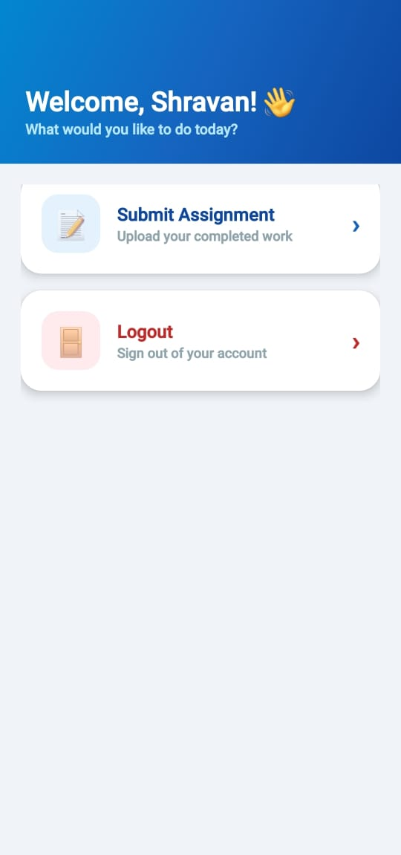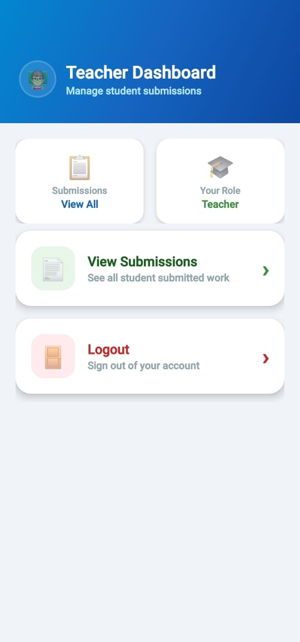

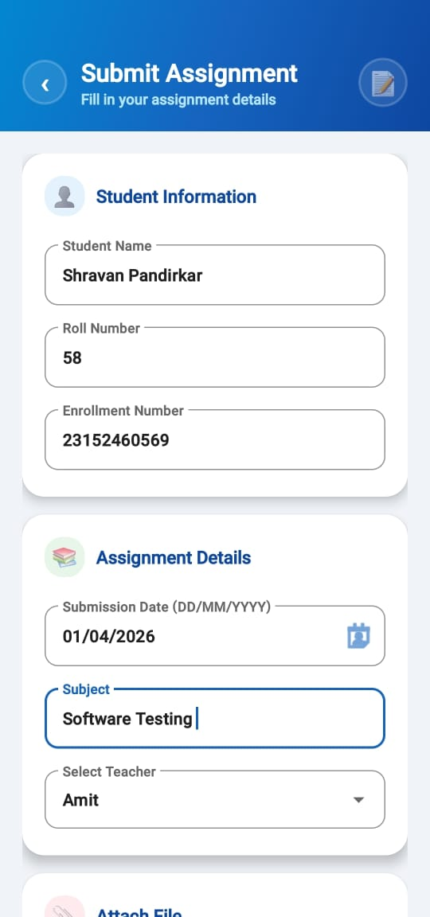
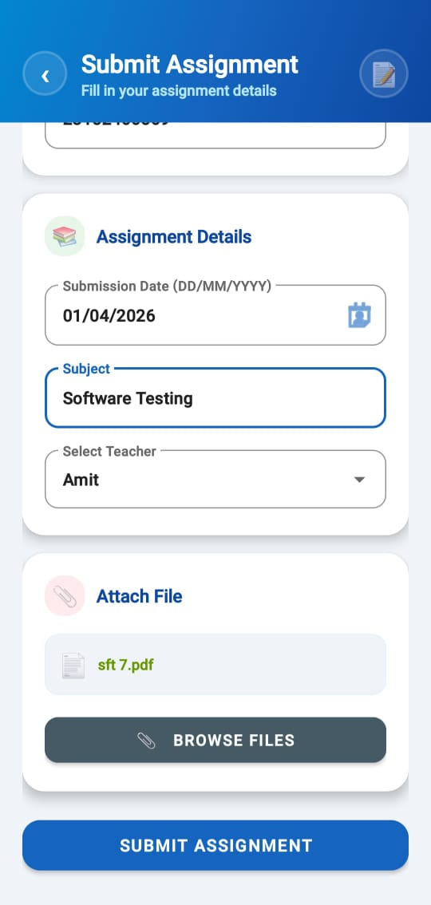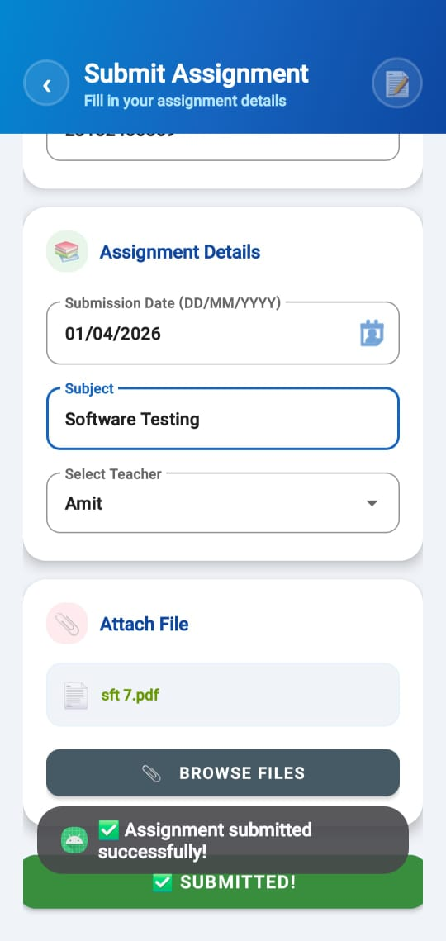

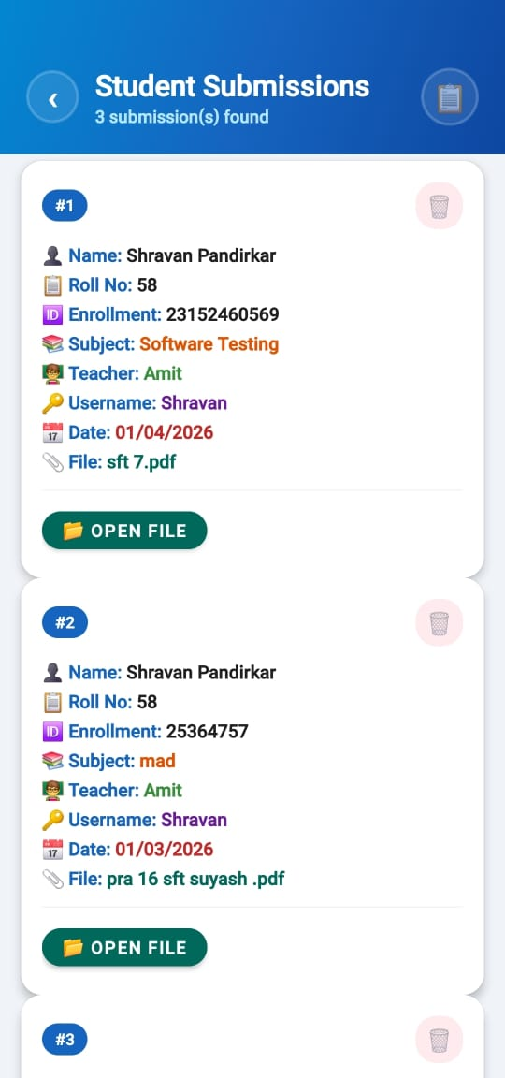

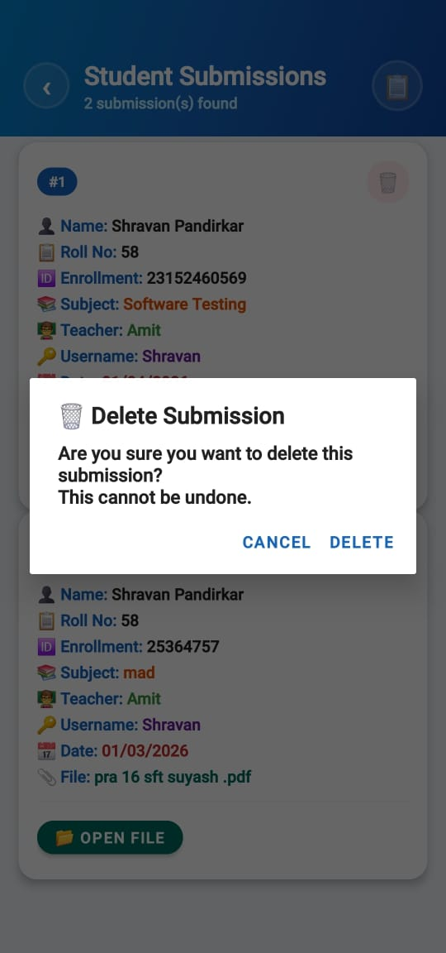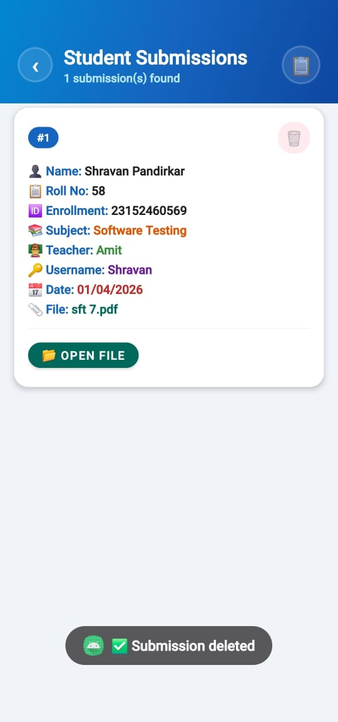

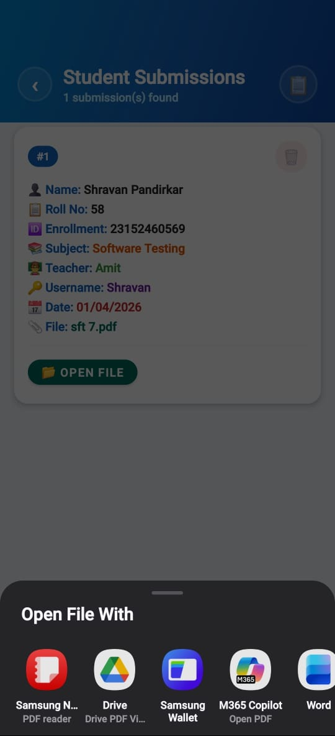

7.0 Actual Resource Used-

Sr. No. | Resources required | Specifications
1 | Computer system | Processor i5, RAM-8GB
2 | Operating System | Windows 11
3 | Developing Software | Android Studio
8.0 Skills Developed
During the course of this micro-project, we learned how to design and implement a Digital Assignment Submission Application using Android and Java/Kotlin.
- By working on this project, we developed teamwork skills and learned how to coordinate effectively with team members during application development.
- This project helped us improve our Android programming skills, especially in Java/Kotlin-based mobile application development.
- We gained practical knowledge by applying theoretical concepts to a real-world problem related to managing digital assignment submissions.
- We learned how to design and develop user-friendly interfaces using XML layouts in Android Studio.
- We developed skills to store and manage data efficiently using SQLite/Firebase for handling assignment submission records.
- We learned how to implement user input validation, file upload handling, and error management to improve application reliability.
- We gained experience in implementing multiple activities such as Login, Register, Upload Assignment, and View Submissions screens within the application.
- We improved our debugging and testing skills by identifying and fixing errors during application development to ensure smooth functioning.
9.0 Applications of this Micro-Project
9.1.1 This application can be used in colleges and schools to help students submit assignments digitally in an organized manner.
9.1.2 It enables students to upload assignment files easily without relying on physical paper submissions or unorganized communication channels.
9.1.3 Teachers can view, download, and verify assignment submissions quickly through a centralized system.
9.1.4 It can be used by coaching institutes, training centers, and educational organizations to manage assignment submissions efficiently.
9.1.5 The application reduces paperwork and manual effort by storing assignment details in a digital database.
9.1.6 The application can be extended by adding teacher dashboards, deadline notifications, grading systems, and cloud storage integration for better management in the future.

10.0 Conclusion
The Digital Assignment Submission Application developed in this micro-project provides an efficient and reliable solution for managing assignment submissions digitally by replacing traditional manual methods such as paper-based submissions, email attachments, and physical file collection. The system allows students to upload assignments easily, store submission details securely in a database, and retrieve submitted work whenever required, making the submission process faster, paperless, and more convenient.
During the development of this project, we performed requirement analysis, designed a user-friendly interface using XML layouts, implemented the application using Java/Kotlin and Android Studio, tested various modules, and made necessary improvements to ensure proper functionality. Proper documentation was also prepared to explain the working, features, and structure of the application.
Overall, this project enhanced our Android development skills, programming knowledge, problem-solving ability, and teamwork skills, while providing practical exposure to real-world mobile application development. The application can be further improved by adding new features such as a teacher evaluation panel, grading system, push notifications for deadlines, cloud database integration, and analytics for submission tracking in future versions.

11.0 References:

11.1.1 Java Programming Books (MSBTE Curriculum / Textbooks)
11.1.2 Oracle Java Documentation – https://docs.oracle.com/javase/
11.1.3 W3Schools – https://www.w3schools.com/java/
11.1.4 GeeksforGeeks – https://www.geeksforgeeks.org/java/
11.1.5 Online tutorials and videos related to Java GUI and application development
11.1.6 Book -“Android App Development for Dummies” – Michael Burton & Donn Felker


Smt. Geeta D. Tatkare Polytechnic, Gove, Kolad

Department of Computer Engineering

Microproject Evaluation Sheet
Institute Code:1581
Academic Year:2025-26 Program: Computer Engineering Course: Mobile Application Development Course Code:316006
Semester: Sixth Date of Evaluation:

- Title of the Microproject: Digital Assignment Submission App
- Course Outcomes Achieved:
CO1 - Interpret the features of android operating system.
CO2 - Use after configuring Android development environment.
CO3 - Develop android applications using UI components and layouts.
CO4 - Create database driven Android applications.

- Evaluation:

Enrollment No. | Seat No. | Name of Student | Process and Product Assessment (6 Marks) | Individual Presentation/Viva (4 Marks) | Total Marks 10
23152460569 | 148142 | Shravan Suresh Pandirkar

Date: Evaluated by

Name & Signature of Faculty Mrs. Anuja Suryavansh

